## Topics in a glance:

1. **Spring MVC Architecture**
2. **Spring Boot**
3. **Spring Boot with Rest APIs**
4. **Spring Data JPA**
5. **Synchronous Vs Asynchronous Programming**
6. **Small project to demonstrate Spring Cloud including Fault tolerance, Load Balancers, API Gateway.**
7. Spring Boot with React
8. Databases RDBMS (Native Queries, Stored Procedure, Indexes, Views, Triggers etc)
9. Java 8 Features Lambdas, Functional Programming, Streams etc.
10. Collections Framework:
11. Overriding & Overloading / Dynamic Polymorphism:
12. Multithreading & Concurrency:
13. Java Concurrency API including Executor Service, Semaphores etc
14. Docker and Kubernetes.
15. DevOps – GIT, Jenkins, Ansible, Puppet etc.

## 

## Spring MVC Flow

## Client (Browser) requests for a Resource in the web Application.

## 

## The Spring front controller i.e, DispatcherServlet first receives the request.

## 

## DispatcherServlet consults the HandlerMapping to identify the particular controller for the given URL.

## 

## HandlerMapping identifies the controller for the given request and sends to the DispatcherServlet.

## 

## DispatcherServlet will call the handleRequest(request,response) method on Controller. A Controller is developed by writing a simple java class which implements Controller interface or extends its adapter class.

## 

## Controller will call the business method according to business requirement.

## 

## Service class will call the DAO class method for business data.

## 

## DAO interacts with DB to get data.

## 

## DAO returns same data to service.

## 

## Fetched data will be processed according to business requirement and return results to Controller.

## 

## The Controller returns the Model and View in the form of Object back to the Controller i.e, DispatcherServlet.

## 

## The front controller i.e, DispatcherServlet then tries to resolve the actual View which may be JSP,velocity or Free Marker by consulting the View Resolver Object.

## 

## ViewResolver selected view is rendred back to the DispatcherServlet.

## 

## DispatcherServletconsult the particular view with the model.

## 

## View executes and returns HTML output to the DispatcherServlet.

## 

## DispatcherServlet will sends the output to the Browser.

## @Entity

## @Table(name="COURSES")

## public class Course {

## private long courseId;

## private String courseName;

## 

## public Course() {

## }

## 

## public Course(String courseName) {

## this.courseName = courseName;

## }

## 

## @Id

## @GeneratedValue

## @Column(name="COURSE_ID")

## public long getCourseId() {

## return this.courseId;

## }

## 

## public void setCourseId(long courseId) {

## this.courseId = courseId;

## }

## 

## @Column(name="COURSE_NAME", nullable=false)

## public String getCourseName() {

## return this.courseName;

## }

## 

## public void setCourseName(String courseName) {

## this.courseName = courseName;

## }

## }

## **@RequestBody** and **@ResponseBody** annotations are used to bind the HTTP request/response body with a domain object in method parameter or return type. Behind the scenes, these annotation uses **HTTP Message converters** to convert the body of HTTP request/response to domain objects.

## **@RequestBody**

## If a method parameter is annotated with @RequestBody, Spring will bind the incoming HTTP request body(for the URL mentioned in @RequestMapping for that method) to that parameter. While doing that, Spring will [behind the scenes] use HTTP Message converters to convert the HTTP request body into domain object **[deserialize request body to domain object]**, based on **Accept** header present in request.

## @RequestMapping(value="/user/create", method=RequestMethod.POST)

## public ResponseEntity<Void> createUser(@RequestBody User user, UriComponentsBuilder ucBuilder){

## System.out.println("Creating User "+user.getName());

## 

## if(userService.isUserExist(user)){

## System.out.println("A User with name "+user.getName()+" already exist");

## return new ResponseEntity<Void>(HttpStatus.CONFLICT);

## }

## userService.saveUser(user);

## 

## 

| **HttpMessageConverter Implementations** | |
| --- | --- |
| **MessageConverter** | **Description** |
| **StringHttpMessageConverter** | An HttpMessageConverter implementation that can read and write String instances from the HTTP request and response. By default, this converter supports all text media types (text/*) and writes with a Content-Type of text/plain. |
| FormHttpMessageConverter | An HttpMessageConverter implementation that can read and write form data from the HTTP request and response. By default, this converter reads and writes the application/x-www-form-urlencoded media type. Form data is read from and written into a MultiValueMap<String, String>. The converter can also write (but not read) multipart data read from a MultiValueMap<String, Object>. By default, multipart/form-data is supported. As of Spring Framework 5.2, additional multipart subtypes can be supported for writing form data. Consult the javadoc for FormHttpMessageConverter for further details. |
| ByteArrayHttpMessageConverter | An HttpMessageConverter implementation that can read and write byte arrays from the HTTP request and response. By default, this converter supports all media types (*/*) and writes with a Content-Type of application/octet-stream. You can override this by setting the supportedMediaTypes property and overriding getContentType(byte[]). |
| MarshallingHttpMessageConverter | An HttpMessageConverter implementation that can read and write XML by using Spring’s Marshaller and Unmarshaller abstractions from the org.springframework.oxm package. This converter requires a Marshaller and Unmarshaller before it can be used. You can inject these through constructor or bean properties. By default, this converter supports text/xml and application/xml. |
| **MappingJackson2HttpMessageConverter** | An HttpMessageConverter implementation that can read and write JSON by using Jackson’s ObjectMapper. You can customize JSON mapping as needed through the use of Jackson’s provided annotations. When you need further control (for cases where custom JSON serializers/deserializers need to be provided for specific types), you can inject a custom ObjectMapper through the ObjectMapper property. By default, this converter supports application/json. |
| **MappingJackson2XmlHttpMessageConverter** | An HttpMessageConverter implementation that can read and write XML by using [Jackson XML](https://github.com/FasterXML/jackson-dataformat-xml) extension’s XmlMapper. You can customize XML mapping as needed through the use of JAXB or Jackson’s provided annotations. When you need further control (for cases where custom XML serializers/deserializers need to be provided for specific types), you can inject a custom XmlMapper through the ObjectMapper property. By default, this converter supports application/xml. |
| SourceHttpMessageConverter | An HttpMessageConverter implementation that can read and write javax.xml.transform.Source from the HTTP request and response. Only DOMSource, SAXSource, and StreamSource are supported. By default, this converter supports text/xml and application/xml. |
| BufferedImageHttpMessageConverter | An HttpMessageConverter implementation that can read and write java.awt.image.BufferedImage from the HTTP request and response. This converter reads and writes the media type supported by the Java I/O API. |

## <dependency>

## <groupId>com.fasterxml.jackson.core</groupId>

## <artifactId>jackson-databind</artifactId>

## <version>${jackson.version}</version>

## </dependency>

## **@ResponseBody**

## If a method is annotated with @ResponseBody, Spring will bind the return value to outgoing HTTP response body. While doing that, Spring will [behind the scenes] use HTTP Message converters to convert the return value to HTTP response body **[serialize the object to response body]**, based on **Content-Type** present in request HTTP header.

## Take this method for example:

|  |
| --- |
| @RequestMapping(value = "/user/all", method = RequestMethod.GET)public @ResponseBody List<User> listAllUsers() {    return userService.findAllUsers();} |

## **NOTE :**As from Spring 4, @RestController is the preferred way to achieve the same functionality earlier provided by @ResponseBody. Under the hood, @RestController is @Controller+@ResponseBody, and it avoids the need of prefixing every method with @ResponseBody.

## Request Mapping Basics

## In Spring MVC applications, the RequestDispatcher (Front Controller Below, Dispatcher Servlet) servlet is responsible for routing incoming HTTP requests to handler methods of controllers.

## When configuring Spring MVC, you need to specify the mappings between the requests and handler methods.

## [Spring MVC Dispatcher Servlet and @RequestMapping](https://i2.wp.com/springframework.guru/wp-content/uploads/2017/09/mvc.png)To configure the mapping of web requests, you use the @RequestMapping annotation.

## The @RequestMapping annotation can be applied to class-level and/or method-level in a controller.

## The class-level annotation maps a specific request path or pattern onto a controller. You can then apply additional method-level annotations to make mappings more specific to handler methods.

## Here is an example of the @RequestMapping annotation applied to both class and methods.

## @RestController

## @RequestMapping("/home")

## public class IndexController {

## @RequestMapping("/")

## String get() {

## //mapped to hostname:port/home/

## return "Hello from get";

## }

## @RequestMapping("/index")

## String index() {

## //mapped to hostname:port/home/index/

## return "Hello from index";

## }

## }

## With the preceding code, requests to /home will be handled by get() while request to /home/index will be handled by index().

## @RequestMapping With Multiple URIs

## You can have multiple request mappings for a method. For that add one @RequestMapping annotation with a list of values.

## @RestController

## @RequestMapping("/home")

## public class IndexController {

## @RequestMapping(value = {

## "",

## "/page",

## "page*",

## "view/*,**/msg"

## })

## String indexMultipleMapping() {

## return "Hello from index multiple mapping.";

## }

## }

## As you can see in this code, @RequestMapping supports wildcards and ant-style paths. For the preceding code, all these URLs will be handled by indexMultipleMapping().

## localhost:8080/home

## localhost:8080/home/

## localhost:8080/home/page

## localhost:8080/home/pageabc

## localhost:8080/home/view/

## localhost:8080/home/view/view

## @RequestMapping With @RequestParam

## The @RequestParam annotation is used with @RequestMapping to bind a web request parameter to the parameter of the handler method.

## The @RequestParam annotation can be used with or without a value. The value specifies the request param that needs to be mapped to the handler method parameter, as shown in this code snippet.

## @RestController

## @RequestMapping("/home")

## public class IndexController {

## @RequestMapping(value = "/id")

## String getIdByValue(@RequestParam("id") String personId) {

## System.out.println("ID is " + personId);

## return "Get ID from query string of URL with value element";

## }

## @RequestMapping(value = "/personId")

## String getId(@RequestParam String personId) {

## System.out.println("ID is " + personId);

## return "Get ID from query string of URL without value element";

## }

## }

## In Line 6 of this code, the request param id will be mapped to the personId parameter personId of thegetIdByValue() handler method.

## The value element of @RequestParam can be omitted if the request param and handler method parameter names are same, as shown in Line 11.

## The required element of @RequestParam defines whether the parameter value is required or not.

## @RestController

## @RequestMapping("/home")

## public class IndexController {

## @RequestMapping(value = "/name")

## String getName(@RequestParam(value = "person", required = false) String personName) {

## return "Required element of request param";

## }

## }

## In this code snippet, as the required element is specified as false, the getName() handler method will be called for both of these URLs:

## /home/name?person=xyz

## /home/name

## The default value of the @RequestParam is used to provide a default value when the request param is not provided or is empty.

## @RestController

## @RequestMapping("/home")

## public class IndexController {

## @RequestMapping(value = "/name")

## String getName(@RequestParam(value = "person", defaultValue = "John") String personName) {

## return "Required element of request param";

## }

## }

## Differences between @RequestParam and @PathVariable annotations in Spring MVC?

## @RequestParam and @PathVariable is used to extract values from the HTTP request, there is a subtle difference between them

## @RequestParam is used to get the request parameters from URL, also known as query parameters, while @PathVariable extracts values from URI. For example, if the incoming HTTP request to retrieve a book on topic "Java" is http://localhost:8080/shop/order/1001/receipts?date=12-05-2017, then you can use the @RequestParam annotation to retrieve the query parameter date and you can use @PathVariable to extract the orderId i.e. "1001" as shown below: @RequestMapping(value="/order/{orderId}/receipts", method = RequestMethod.GET) public List listUsersInvoices(                               @PathVariable("orderId") int order,  @RequestParam(value = "date", required = false) Date dateOrNull) { ... } The required=false denotes that the query parameter can be optional, but the [URL](http://www.java67.com/2013/01/difference-between-url-uri-and-urn.html) must have the same URI.

## In this code, if the person request param is empty in a request, the getName() handler method will receive the default value John as its parameter.

## Using @RequestMapping With HTTP Methods

## The Spring MVC @RequestMapping annotation is capable of handling HTTP request methods, such as GET, PUT, POST, DELETE, and PATCH.

## By default, all requests are assumed to be of HTTP GET type.

## In order to define a request mapping with a specific HTTP method, you need to declare the HTTP method in@RequestMapping using the method element as follows.

## @RestController

## @RequestMapping("/home")

## public class IndexController {

## @RequestMapping(method = RequestMethod.GET)

## String get() {

## return "Hello from get";

## }

## @RequestMapping(method = RequestMethod.DELETE)

## String delete() {

## return "Hello from delete";

## }

## @RequestMapping(method = RequestMethod.POST)

## String post() {

## return "Hello from post";

## }

## @RequestMapping(method = RequestMethod.PUT)

## String put() {

## return "Hello from put";

## }

## @RequestMapping(method = RequestMethod.PATCH)

## String patch() {

## return "Hello from patch";

## }

## }

## In the code snippet above, the method element of the @RequestMapping annotations indicates the HTTP method type of the HTTP request.

## All the handler methods will handle requests coming to the same URL ( /home), but will depend on the HTTP method being used.

## For example, a POST request to /home will be handled by the post() method. While a DELETE request to/home will be handled by the delete() method.

## @RequestMapping Shortcuts

## [Spring 4.3](https://spring.io/blog/2016/06/10/spring-framework-4-3-goes-ga) introduced method-level variants, also known as composed annotations of @RequestMapping. The composed annotations better express the semantics of the annotated methods. They act as wrapper to@RequestMapping and have become the standard ways of defining the endpoints.

## For example, @GetMapping is a composed annotation that acts as a shortcut for @RequestMapping(method =RequestMethod.GET). The method level variants are:

## @GetMapping

## @PostMapping

## @PutMapping

## @DeleteMapping

## @PatchMapping

## The following code shows using the composed annotations.

## @RestController

## @RequestMapping("/home")

## public class IndexController {

## @GetMapping("/person")

## public @ResponseBody ResponseEntity < String > getPerson() {

## return new ResponseEntity < String > ("Response from GET", HttpStatus.OK);

## }

## @GetMapping("/person/{id}")

## public @ResponseBody ResponseEntity < String > getPersonById(@PathVariable String id) {

## return new ResponseEntity < String > ("Response from GET with id " + id, HttpStatus.OK);

## }

## @PostMapping("/person")

## public @ResponseBody ResponseEntity < String > postPerson() {

## return new ResponseEntity < String > ("Response from POST method", HttpStatus.OK);

## }

## @PutMapping("/person")

## public @ResponseBody ResponseEntity < String > putPerson() {

## return new ResponseEntity < String > ("Response from PUT method", HttpStatus.OK);

## }

## @DeleteMapping("/person")

## public @ResponseBody ResponseEntity < String > deletePerson() {

## return new ResponseEntity < String > ("Response from DELETE method", HttpStatus.OK);

## }

## @PatchMapping("/person")

## public @ResponseBody ResponseEntity < String > patchPerson() {

## return new ResponseEntity < String > ("Response from PATCH method", HttpStatus.OK);

## }

## }

## ResponseEntity

## ResponseEntity is meant to represent the entire HTTP response. You can control anything that goes into it: status code, headers, and body.

## @ResponseBody is a marker for the HTTP response body and @ResponseStatus declares the status code of the HTTP response.

## @ResponseStatus isn't very flexible. It marks the entire method so you have to be sure that your handler method will always behave the same way. And you still can't set the headers. You'd need the HttpServletResponse or a HttpHeaders parameter.

## Basically, ResponseEntity lets you do more.

## // Step 1 - Without any options provided

## @RequestMapping(value="/{id}", method=RequestMethod.GET)

## public @ResponseBody Spittle spittleById(@PathVariable long id) {

## return spittleRepository.findOne(id);

## }

## // Step 2- We need to handle exception scenarios, as step 1 only caters happy path.

## @ExceptionHandler(SpittleNotFoundException.class)

## @ResponseStatus(HttpStatus.NOT_FOUND)

## public Error spittleNotFound(SpittleNotFoundException e) {

## long spittleId = e.getSpittleId();

## return new Error(4, "Spittle [" + spittleId + "] not found");

## }

## // Step 3 - Now we will alter the service method, **if you want to provide location**

## @RequestMapping(

## method=RequestMethod.POST

## consumes="application/json")

## public ResponseEntity<Spittle> saveSpittle(

## @RequestBody Spittle spittle,

## UriComponentsBuilder ucb) {

## Spittle spittle = spittleRepository.save(spittle);

## HttpHeaders headers = new HttpHeaders();

## URI locationUri =

## ucb.path("/spittles/")

## .path(String.valueOf(spittle.getId()))

## .build()

## .toUri();

## headers.setLocation(locationUri);

## ResponseEntity<Spittle> responseEntity =

## new ResponseEntity<Spittle>(

## spittle, headers, HttpStatus.CREATED)

## return responseEntity;

## }

## // Step4 - If you are not interested to provide the url location, you can omit ResponseEntity and go with

## @RequestMapping(

## method=RequestMethod.POST

## consumes="application/json")

## @ResponseStatus(HttpStatus.CREATED)

## public Spittle saveSpittle(@RequestBody Spittle spittle) {

## return spittleRepository.save(spittle);

## }

## **@PatchMapping**  annotation for mapping HTTP PATCH requests onto specific handler methods.

## Specifically,  **@PatchMapping**  is a composed annotation that acts as a shortcut for  @RequestMapping (method = RequestMethod.PATCH).

## @PatchMapping Example

## @PatchMapping ( " / patch " )

## public @ResponseBody ResponseEntity < String > patch () {

## return new ResponseEntity < String > ( " PATCH Response " , HttpStatus . OK );

## }

## HTTP Status Codes:

## <https://www.restapitutorial.com/httpstatuscodes.html>

## **Spring Data JPA:**

**Object Relational Impedance Mismatch:**

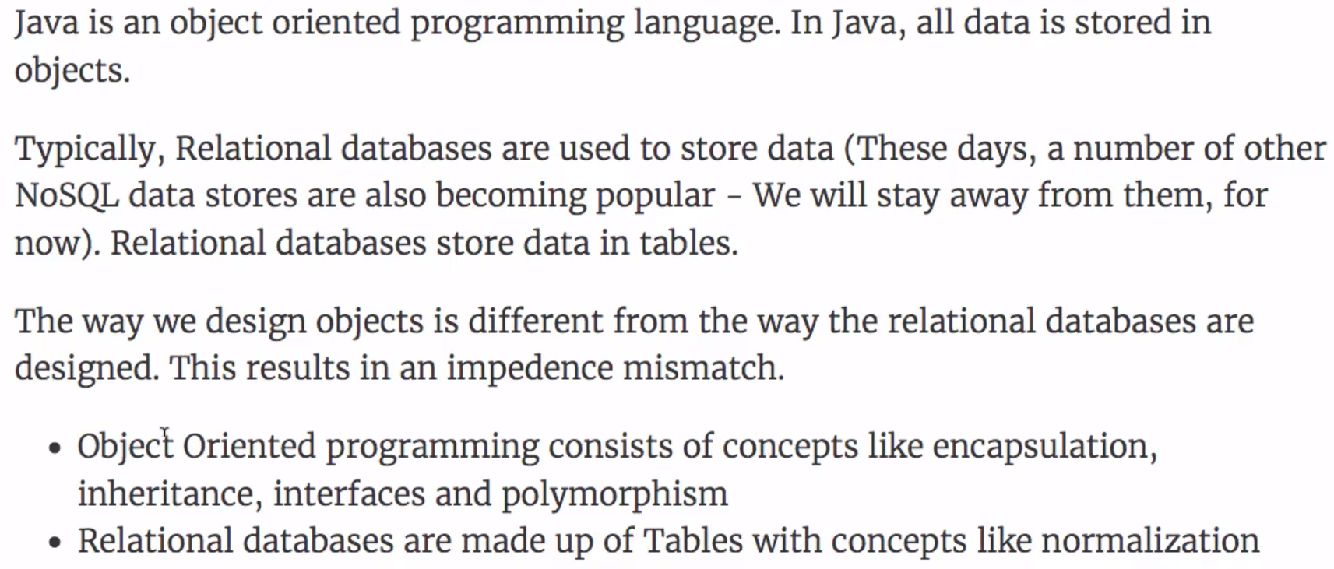

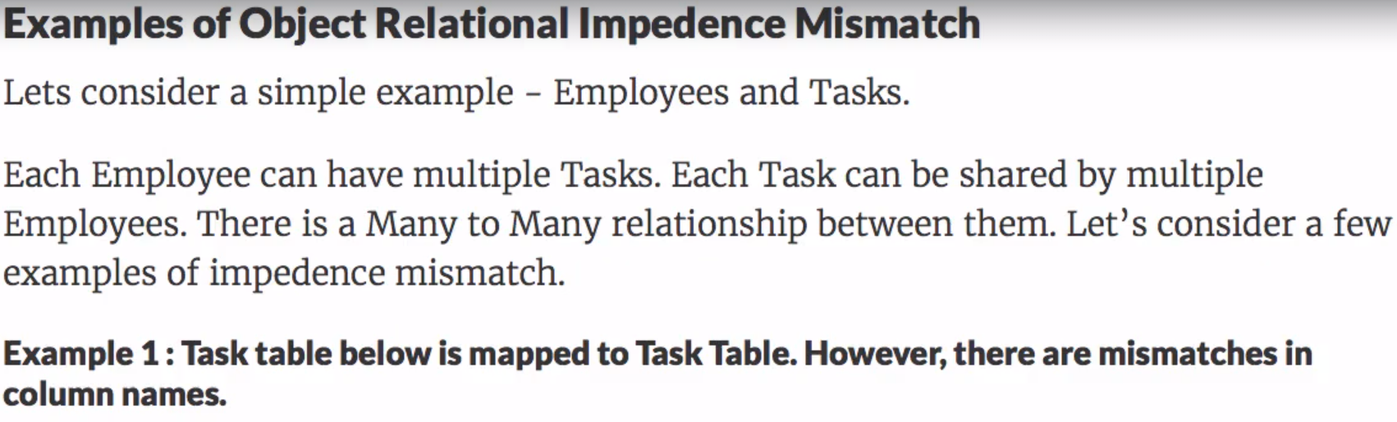

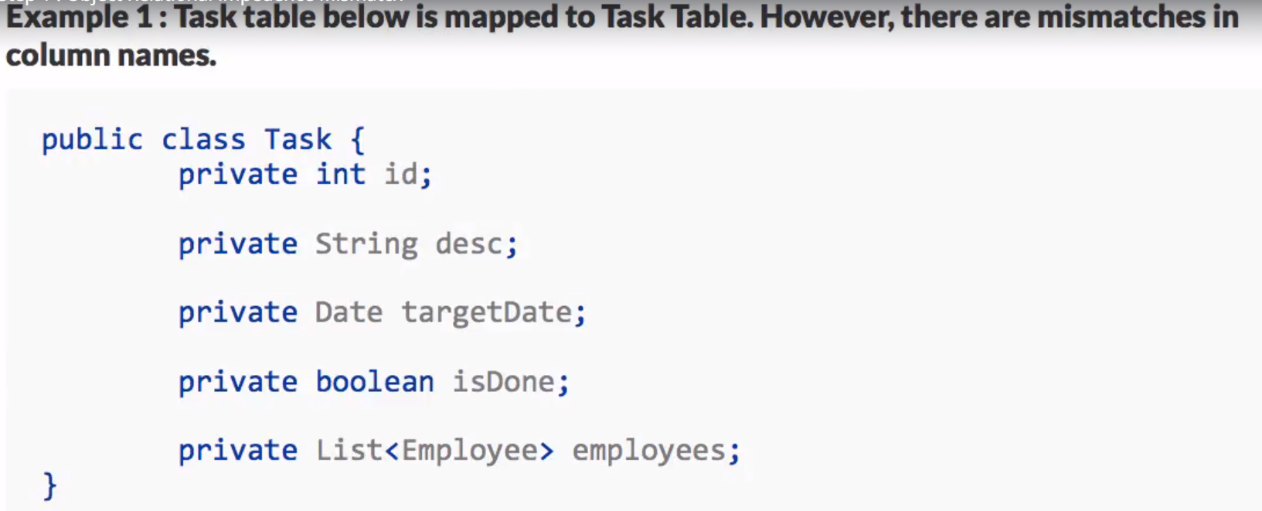

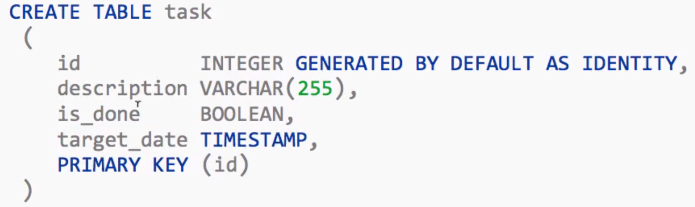

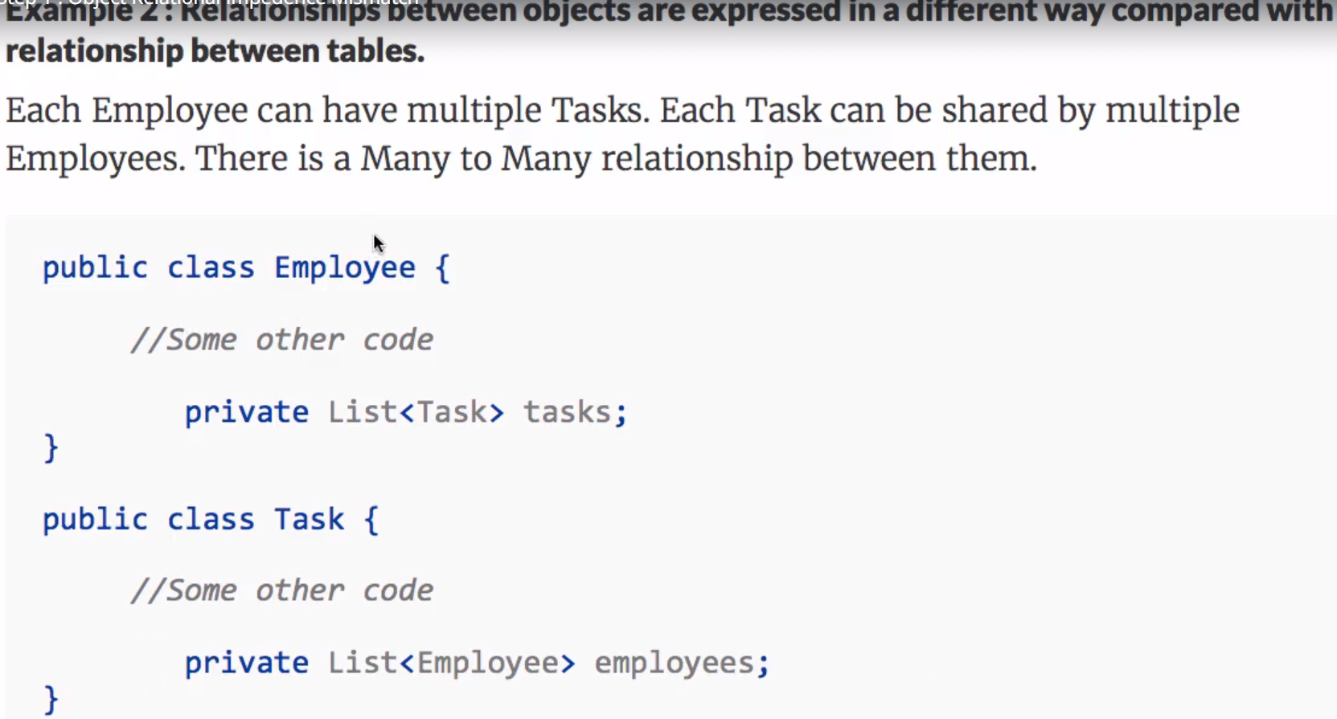

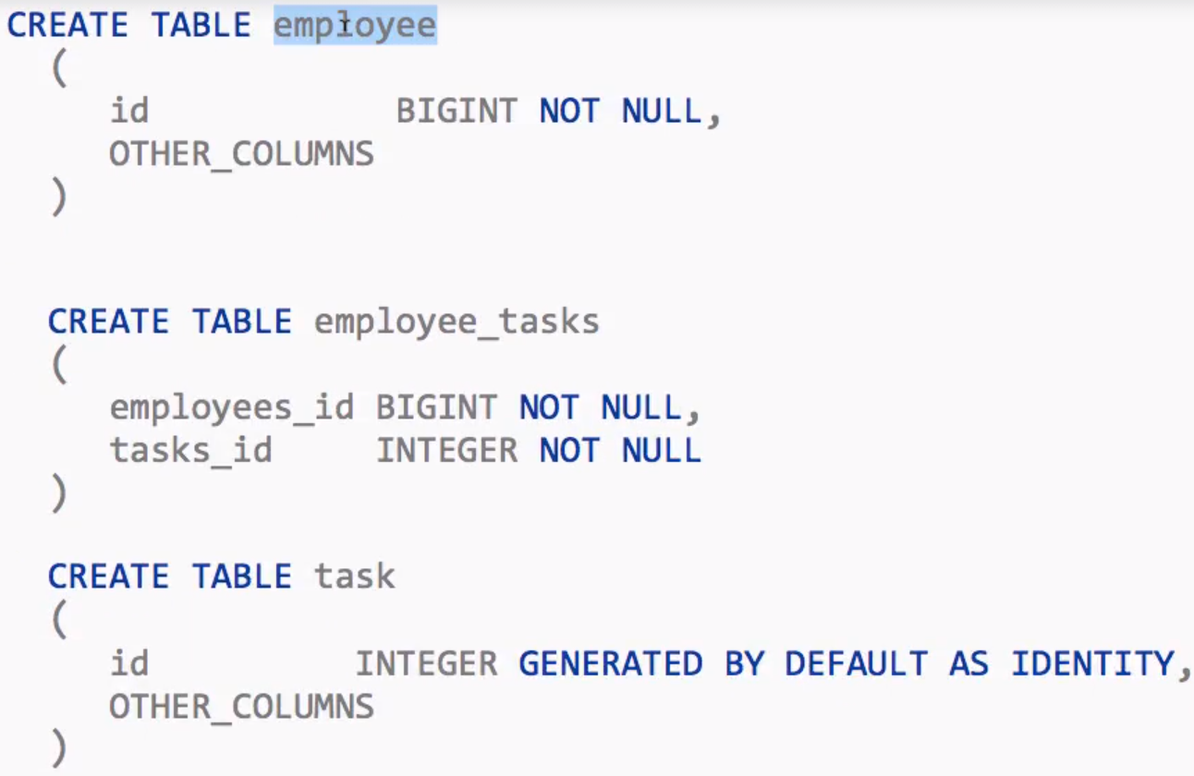

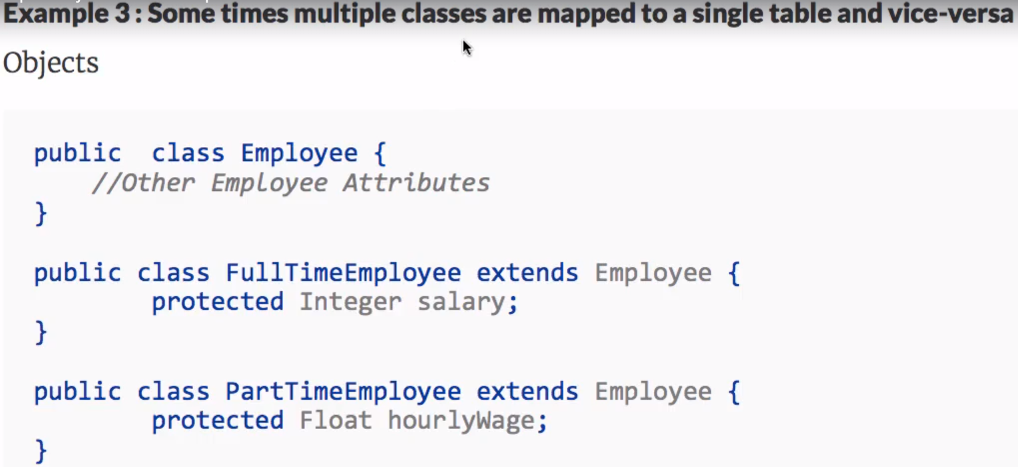

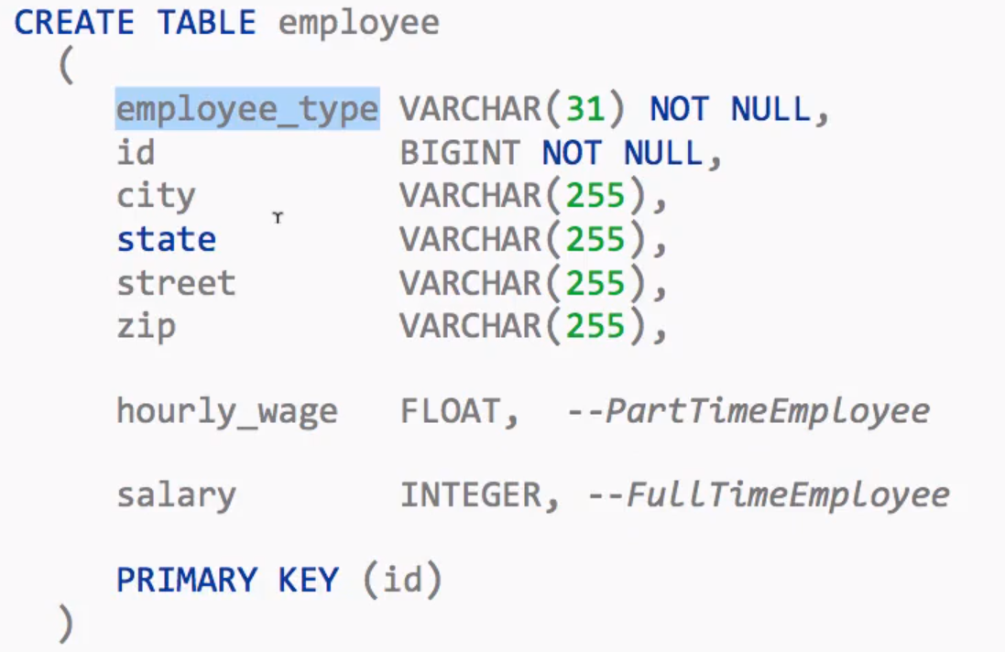

**World before JPA - JDBC, Spring JDBC and myBatis:**

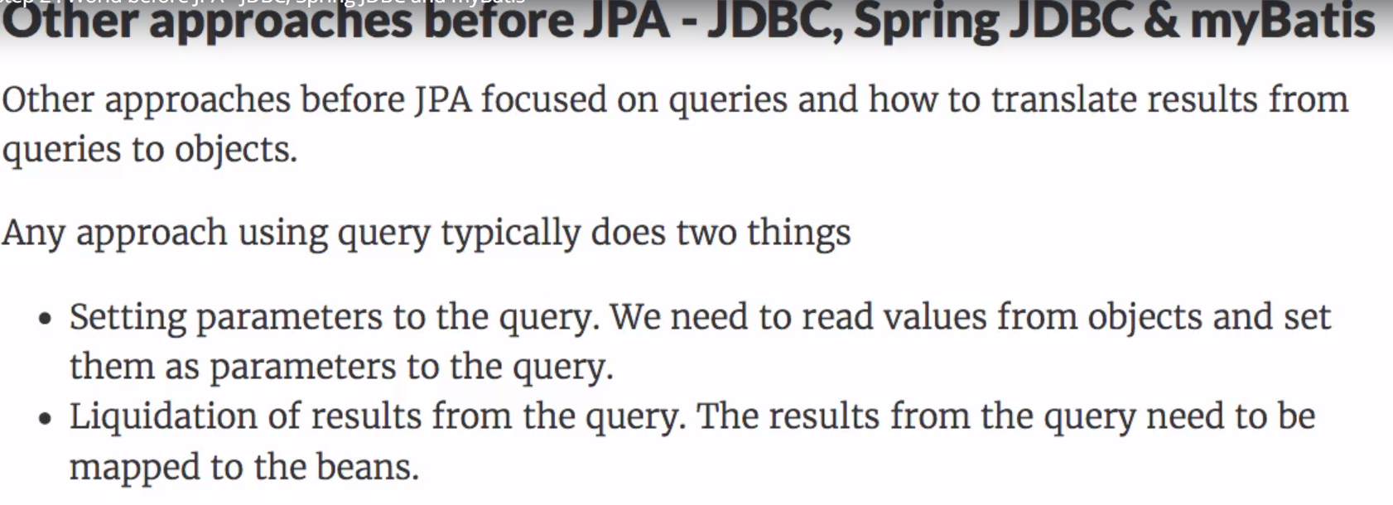

**JDBC**

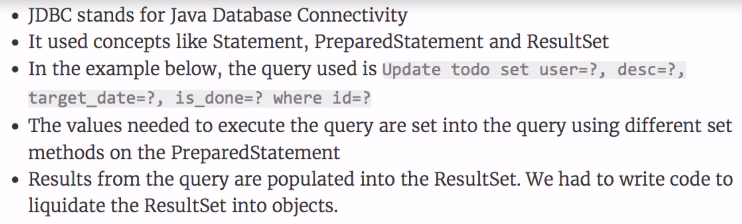

**Update Statement:**

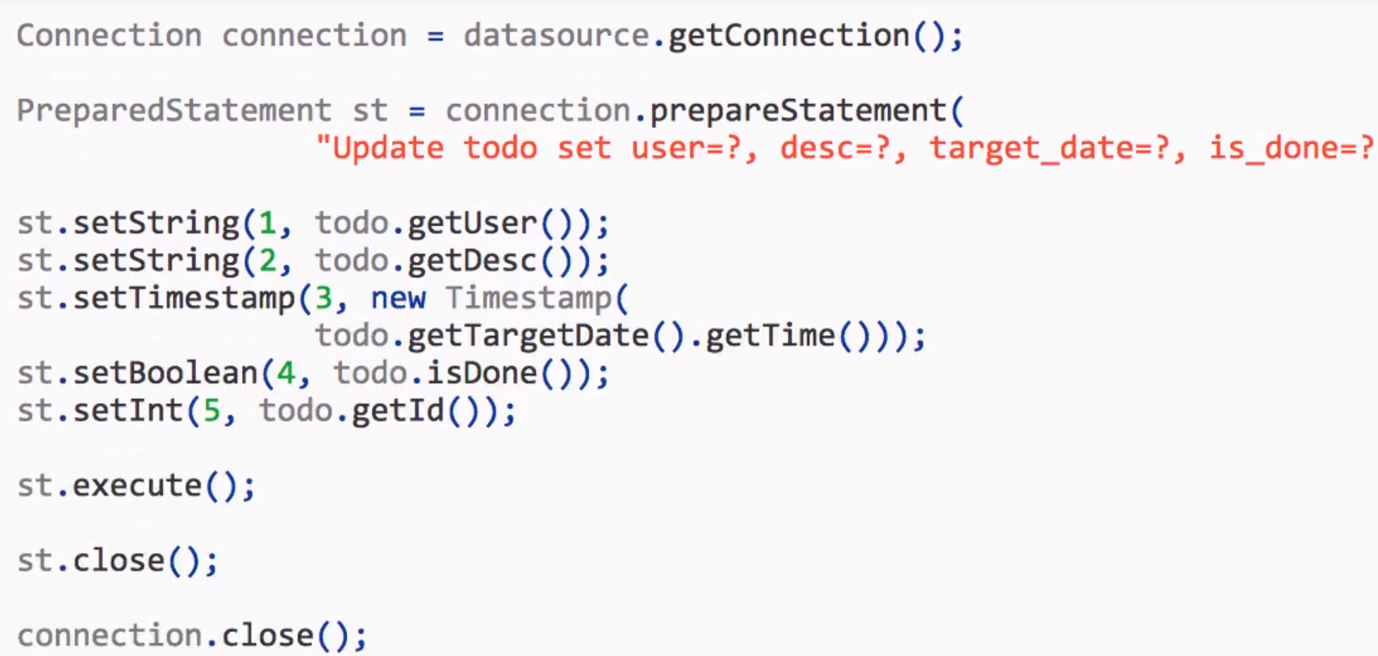

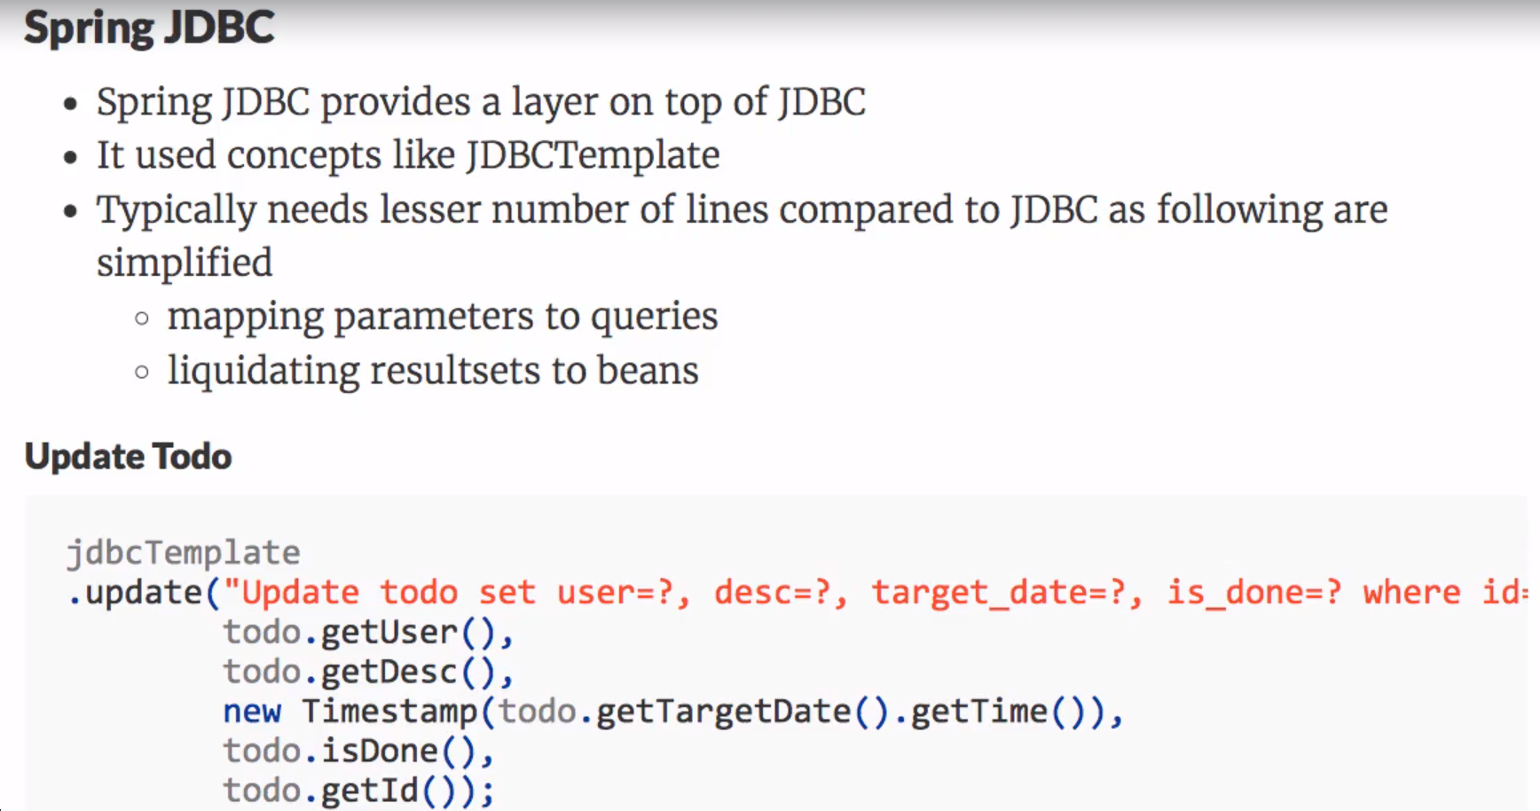

**Reusable Row Mapper:**

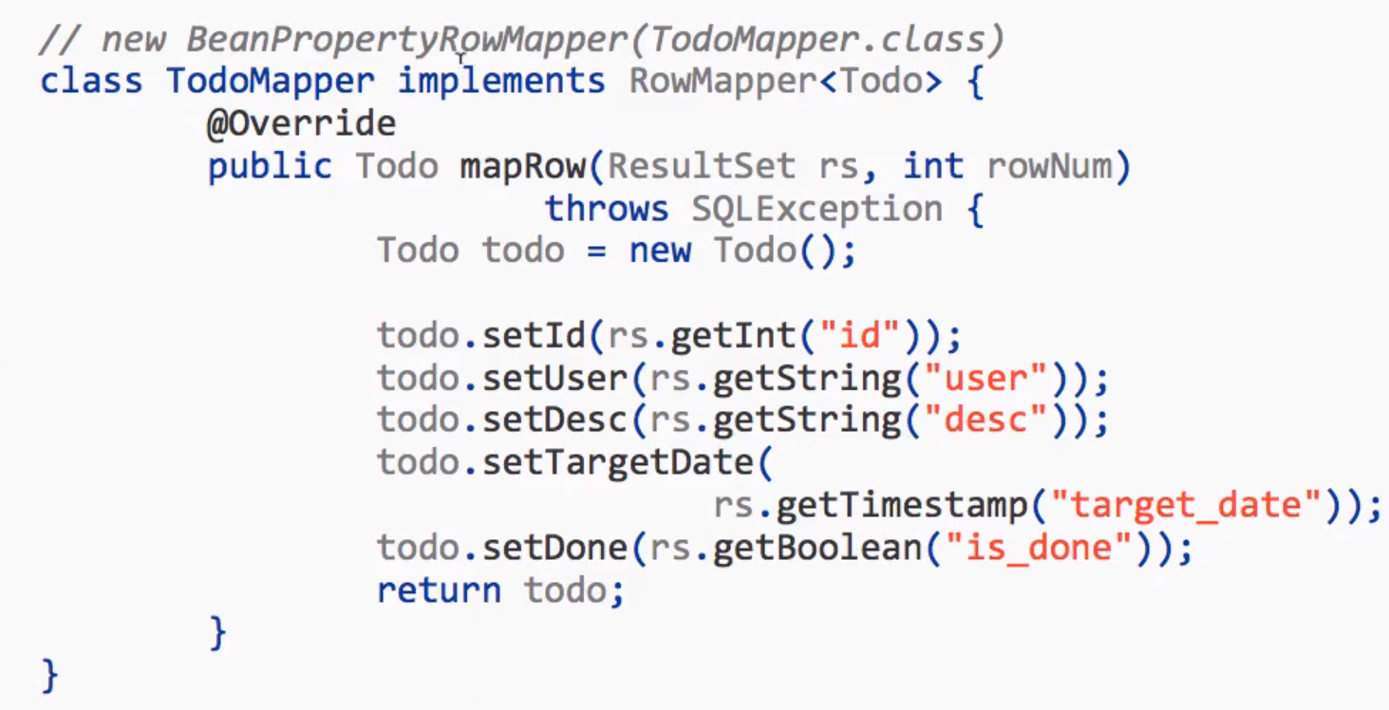

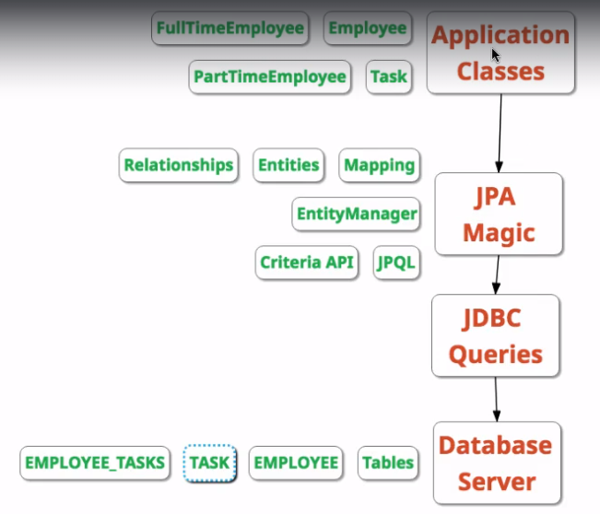

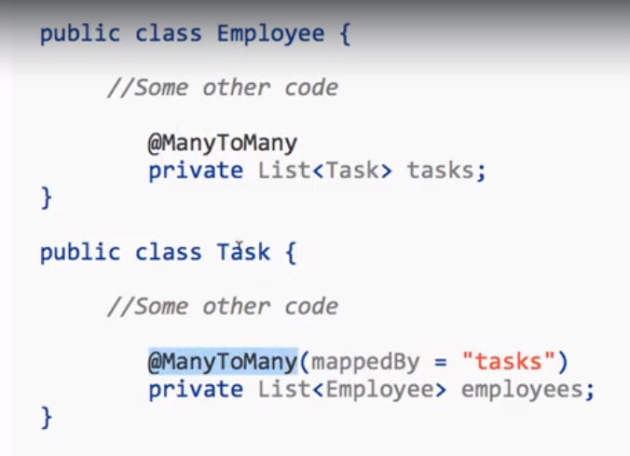

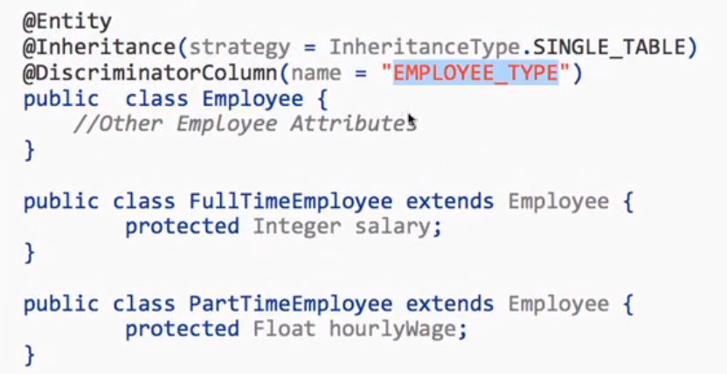

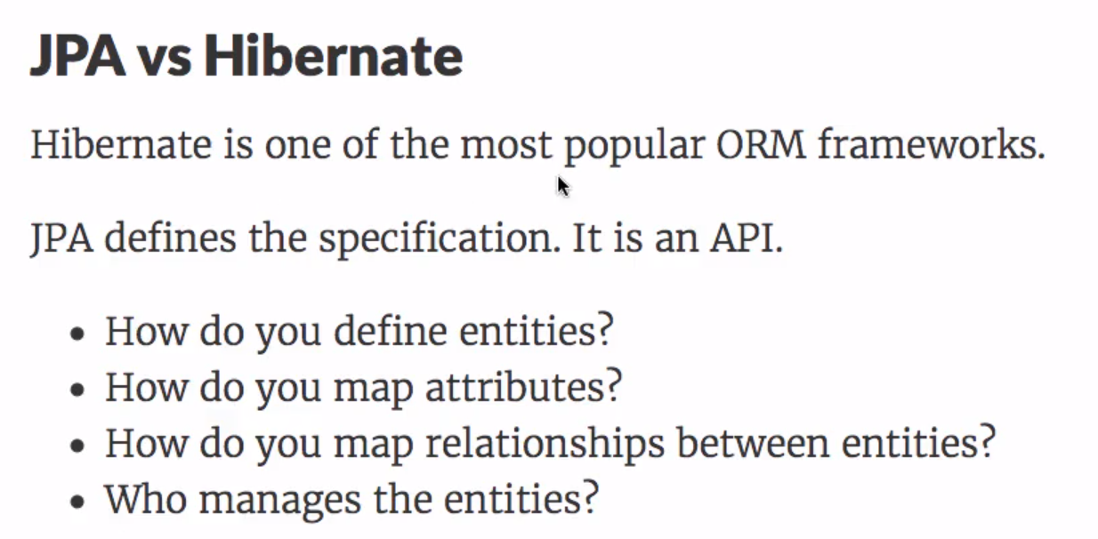

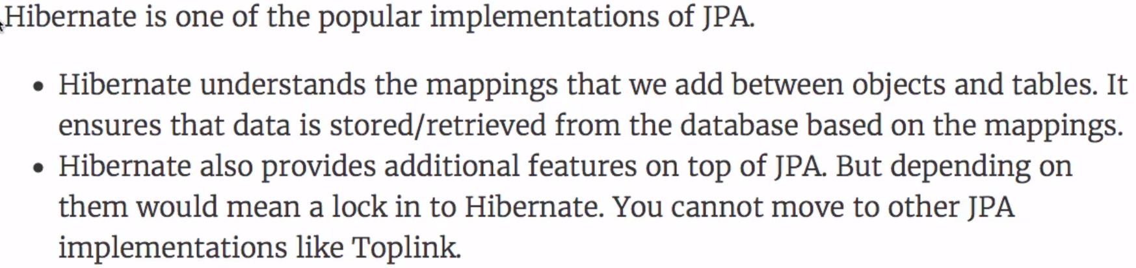

**-------------------------------------------------**

**Model Layer**

**HIBERNATE | iBATIS | TOPLINK | OBJ | Open JPA | ...**

**------------------------------------------------**

**1) POJO classes**

**2) .hbm.xml**

**3) .cfg.xml**

**4) DAO Impl classes**

**JPA (Java Persistence API)**

**==========================**

**1) JPA Specification (JSR-317)**

**-SUN**

**-.pdf (persistence-2_0-final-spec.pdf)**

**-Description**

**2) JP API**

**-SUN**

**-Mostly contains Interfaces**

**-Mostly contains Annotation names**

**-Few classes**

**-javax.persistence package**

**-javax.persistence.* package**

**...**

**3) JPA Implementation**

**-Every ORM Vendor such as Hibernate, Toplink, iBATIS, etc**

**-Have provided impl classes for all interfaces and annotation names in above JP API.**

**-hibernate-jpa-2.0-api-1.0.0.Final.jar**

**Hibernate API - JPA API**

**============= ======**

**Configuration - Persistence**

**SessionFactory - EntityManagerFactory**

**Session - EntityManager**

**Transaction - EntityTransaction**

**buildSessionFactory() - createEntityManagerFactory()**

**openSession() - createEntityManager()**

**beginTransaction() - getTransaction()**

**save()/persist() - persist()**

**load()/get() - find()**

**update()/merge() - merge()**

**delete() - remove()**

**flush() - flush()**

**commit() - commit()**

**getNamedQuery() - createNamedQuery()**

**list() - getResultList()**

**pojos - entities**

**HQL - OQL**

**...**

* **EntityManager Class:**

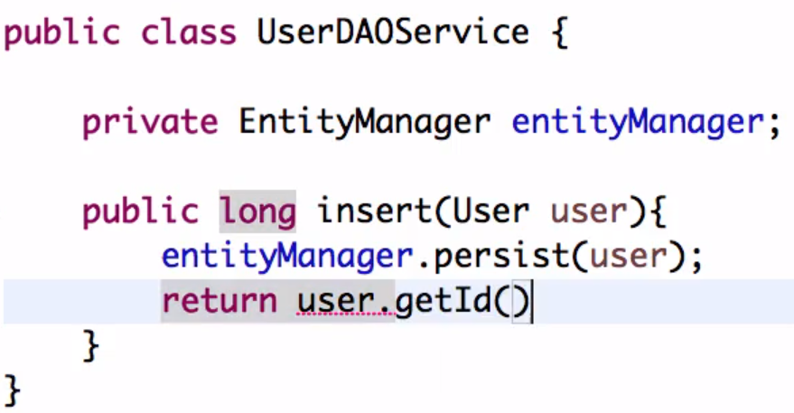

* **@Transactional annotation (Declarative Transaction)**

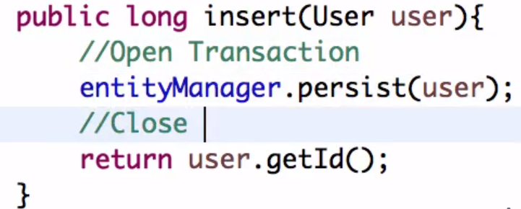

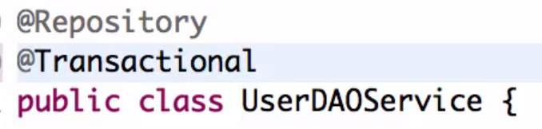

* **Persist method**

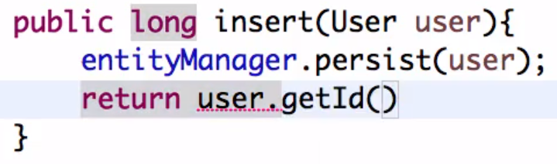

* **@PersistenceContext annotation**

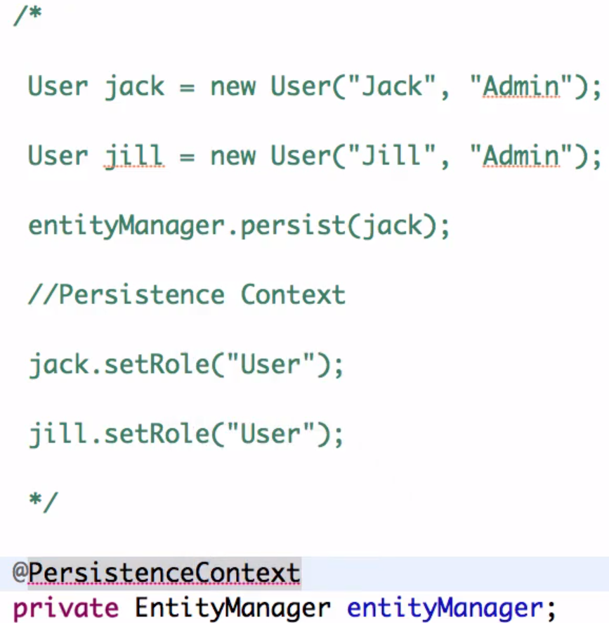

**CommandLineRunner:**

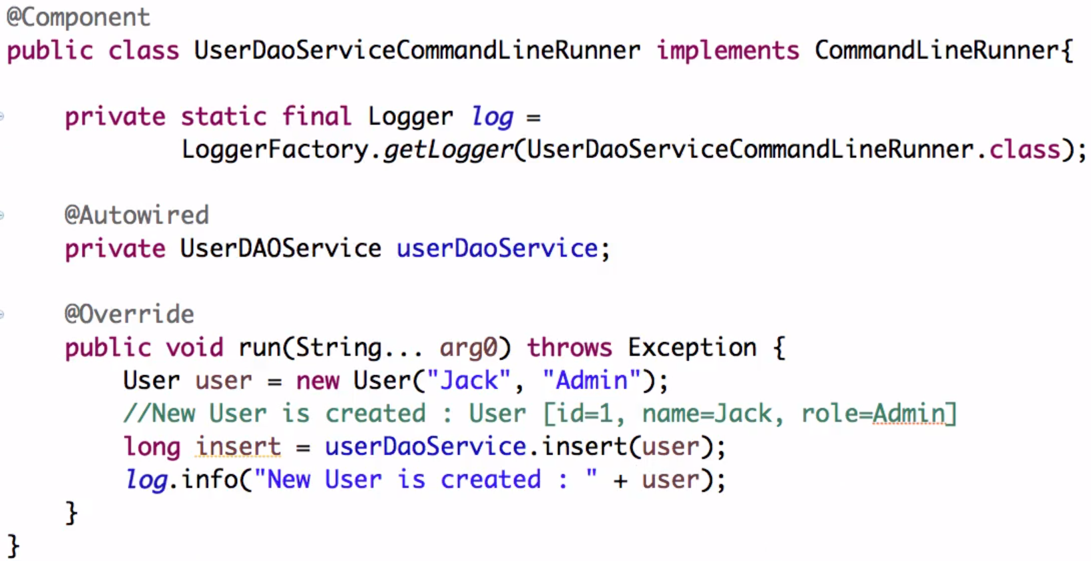



<https://docs.spring.io/spring-data/data-jpa/docs/current/reference/html/#jpa.query-methods.at-query>

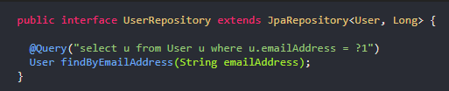

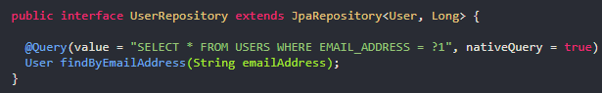

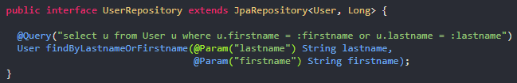

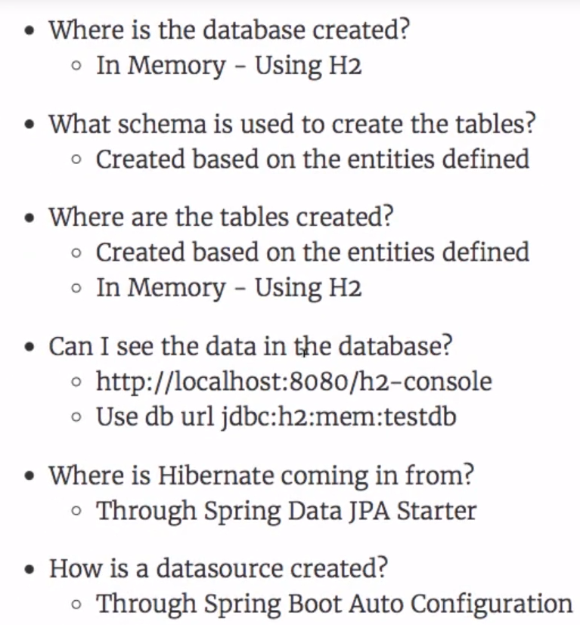

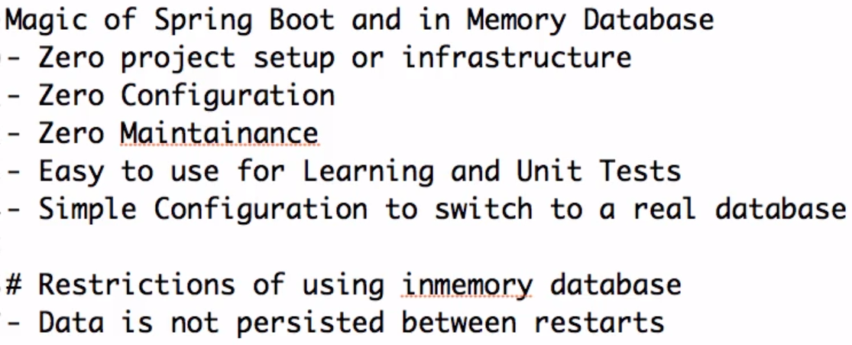

**Spring Boot & Microservices Project:**

1. **Introduction to Microservices**
2. **Challenges with Microservices**
3. **Introduction to Spring Cloud**
4. **Advantages of Microservices Architectures**
5. **Microservice Components - Standardizing Ports and URL**
6. **Intro to Limits Microservice and Spring Cloud Config Server**
7. **Setting up Limits Microservice**
8. **Creating a hard-coded limits service**
9. **Enhance limits service to get configuration from application properties**
10. **Setting up Spring Cloud Config Server**
11. **Installing Git -** <https://git-scm.com/downloads>
12. **Creating Local Git Repository**
13. **Connect Spring Cloud Config Server to Local Git Repository**
14. **Configuration for Multiple Environments in Git Repository**

**Summary:**

* Add two new files as qa and dev environments.

1. **Connect Limits Service to Spring Cloud Config Server**

**Summary:**

* Rename application.properties file to bootstrap.properties
* Application name is the key here.
* Add the below property in bootstrap spring.cloud.config.uri=http://localhost:8888

1. **Debugging problems with Spring Cloud Config Server**

## Debugging problems with Spring Cloud Config Server

First of all check if you have any typos in the URL. Does it match exactly what is given below?

(1) Does the URL <http://localhost:8888/limits-service/default> work? If the URL does not work, check if you have the same name for limits-service in (a) spring.application.name in bootstrap.properties (b) in the URL (c) in the name of the property file

(2) Check if the name in @ConfigurationProperties("limits-service") matches the prefix of property values in application.properties. limits-service.minimum=9 limits-service.maximum=999

(3) Check if you have @EnableConfigServer enabled on SpringCloudConfigServerApplication class

(4) Check if you have the right repository url in /spring-cloud-config-server/src/main/resources/application.properties - spring.cloud.config.server.git.uri=file:///D:/Jaffar/Education/SPRING MICROSERVICES/SpringBootCurrencyProject/git-local-configuration-repo

(5) Do not have any spaces in your git repository path.

(6) If you are on windows, make sure that you are using one of these formats for your git repository

file:\\C:/WORKSPACE/GIT/git-localconfig-repo

file:///C:/microservices/git-localconfig-repo

file:///C:/Users/Gautham/Documents/workspace-sts-3.9.4.RELEASE/git-localconfig-repo

file:\\C:/Users/Gautham/Documents/workspace-sts-3.9.4.RELEASE/git-localconfig-repo

(7) Make sure that you have the right code - Compare against the code below.

(8) Make sure that you have committed all the code to GIT Local Repo

**If everything is fine**

(1) Stop all the servers

(2) Launch Config Server First

(3) Launch Limits Service

(4) Wait for 2 minutes

**If you still have a problem, post a question including all the details:**

(1) Response for <http://localhost:8080/limits>

(2) Response for <http://localhost:8888/limits-service/default>

(3) Response for <http://localhost:8888/limits-service/dev>

(4) Start up logs for limits-service and spring cloud config server with debug mode enabled

### Why should we use Spring Cloud Config Server?

Lets say you have 100 micro services. Let’s say the configuration for them is stored in 100 different repositories.

Who would maintain this configuration for stage and production environments? The operations team (with support from dev team)

When ever there is a change in configuration, the operations teams need to locate the right repository and make the change.

Compare this with having just one git repository for all the configuration!

As soon as you commit the change to git, the change will be picked up by the application.

Think about the flexibility it provides.

Spring Config Server Supports

* Git
* SVN (Subversion) SVN Example - <https://github.com/spring-cloud-samples/svn-config-server>

### application.properties vs bootstrap.properties

bootstrap.properties helps your application locate the application configuration on the config server.

application.properties contains your default application configuration.

Here's the complete configuration hierarchy. bootstrap is at the top of the tree.

* <https://cloud.spring.io/spring-cloud-commons/multi/multi__spring_cloud_context_application_context_services.html#_the_bootstrap_application_context>
* <https://cloud.spring.io/spring-cloud-config/single/spring-cloud-config.html#_quick_start>

### How do Spring Cloud Config Server and the Limits Service Application Talk to Each Other?

Overview - At startup, your application tells the Spring Config Server, what its application name is. Spring Config Server returns configuration based on it.

For limits-server we configured bootstrap properties to contain the following properties:

/limits-service/src/main/resources/bootstrap.properties

* spring.application.name=limits-service
* spring.cloud.config.uri=http://localhost:8888

At startup of limits service, the request is sent to this URL - <http://localhost:8888/limits-service/default>

How is this URL Formed?

Notice that spring.application.name in bootstrap.properties matches the application name in URL.

Spring config server looks for limits-service.properties and returns the response.

### How does <http://localhost:8888/limits-service/dev> work?

* APP_NAME = limits-service
* PROFILE = dev

Spring config server looks for

* limits-service-dev.properties with priority over
* limits-service.properties

Here's the cloud config server URL Patterns

The HTTP service has resources in the following form:

/{application}/{profile}[/{label}]

/{application}-{profile}.yml

/{label}/{application}-{profile}.yml

/{application}-{profile}.properties

/{label}/{application}-{profile}.properties

A Few more Examples

* limits-service-dev.properties => config-server-url/limits-service/dev
* limits-service-qa.properties => config-server-url/limits-service/qa

### Secure your git repository Spring Cloud Config Server

You can enable security on the git repository.

spring:

cloud:

config:

server:

git:

uri: https://github.com/spring-cloud-samples/config-repo

username: trolley

password: strongpassword

For another security layer, you can encrypt with a secret key each value in the git repository:

example :

spring:

datasource:

url: '{cipher}bade81d32a7ec44d4e'

username: '{cipher}dbe76ffb15e4ec'

password: '{cipher}ghyb15e4ec8d5'

<https://www.devglan.com/spring-cloud/encrypt-decrypt-cloud-config-properties>

1. **Configuring Profiles for Limits Service**

**Summary:**

* Add the below property in bootstrap spring.profiles.active=dev
* Remove the maximum value from dev profile and it should pick up from default

1. **A review of Spring Cloud Config Server**

**Summary:**

* Review all the steps performed until now.

1. **Introduction to Currency Conversion and Currency Exchange Microservices**

**Summary:**

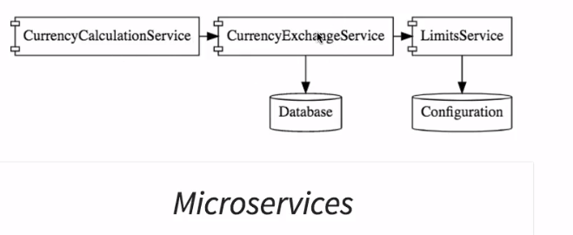

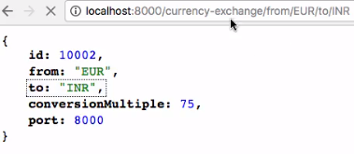

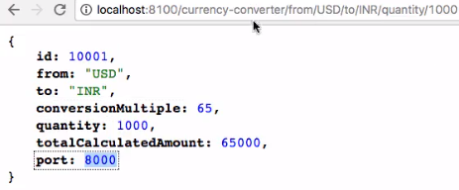

1. **Setting up Currency Exchange Microservice**

**Summary:**

* Create a new Currency Exchange project.

spring.application.name=currency-exchange-service

server.port=8000

1. **Create a simple hard coded currency exchange service**

**Summary:**

* Create a new CurrencyExchangeController.
* Create a new ExchangeValue class.

@GetMapping("/currency-exchange/from/{from}/to/{to}")

**public** ExchangeValue retrieveExchangeValue(@PathVariable String from, @PathVariable String to) {

**return** **new** ExchangeValue(1000L, from, to, **new** BigDecimal(65.0));

}

1. **Setting up Dynamic Port in the Response**

**Summary:**

* Return a port back from currency exchange service response.
* Get the port from the environment interface.

exchangeValue.setPort(Integer.*parseInt*(environment.getProperty("local.server.port")));

* Get the port from the environment interface.
* Create a new copy under run configurations and run it on 8001.

-Dserver.port=8001

1. **Configure JPA and Initialized Data**

**Summary:**

* Add pom dependencies for in memory h2 database.

<dependency>

<groupId>org.springframework.boot</groupId>

<artifactId>spring-boot-starter-data-jpa</artifactId>

</dependency>

<dependency>

<groupId>com.h2database</groupId>

<artifactId>h2</artifactId>

</dependency>

* Create a data.sql and insert few records.
* Make your java class as entity
* Access the url using <http://localhost:8000/h2-console/>

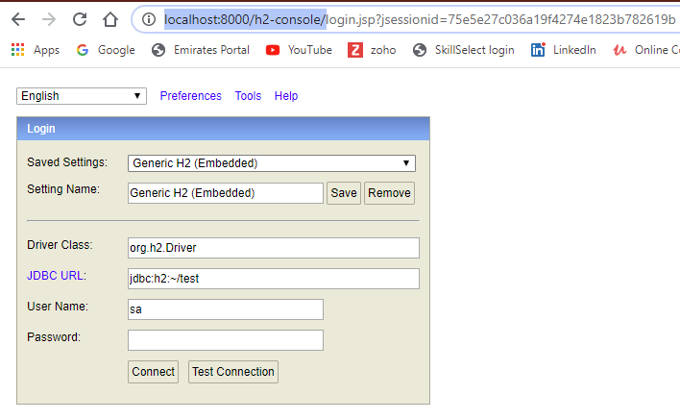

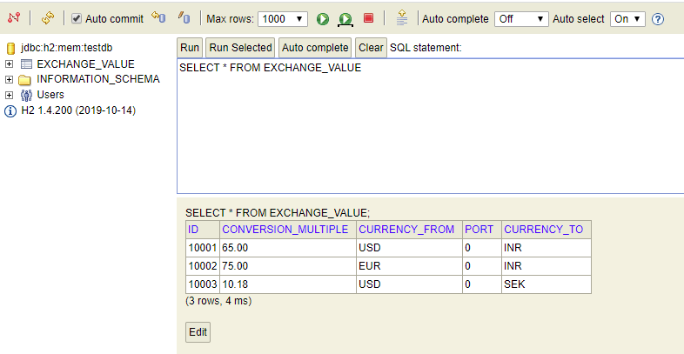

**Trouble shooting steps:**

* Check if the JRE is pointing from a Jdk.
* Even then not working then add below properties in application.properties

spring.jpa.show-sql=true

spring.h2.console.enabled=true

spring.datasource.url=jdbc:h2:mem:testdb

spring.datasource.driverClassName=org.h2.Driver

spring.datasource.username=sa

spring.datasource.password=

spring.jpa.database-platform=org.hibernate.dialect.H2Dialect

1. **Create a JPA Repository**

**Summary:**

* Create an interface named ExchangeValueRepository extends JpaRepository.
* Create a Queryparam method in the repository.
* In the controller class use this repository to get values from the database.

1. **Setting up Currency Conversion Microservice**

**Summary:**

* Create a new Currency Conversion project.

spring.application.name=currency-conversion-service

server.port=8100

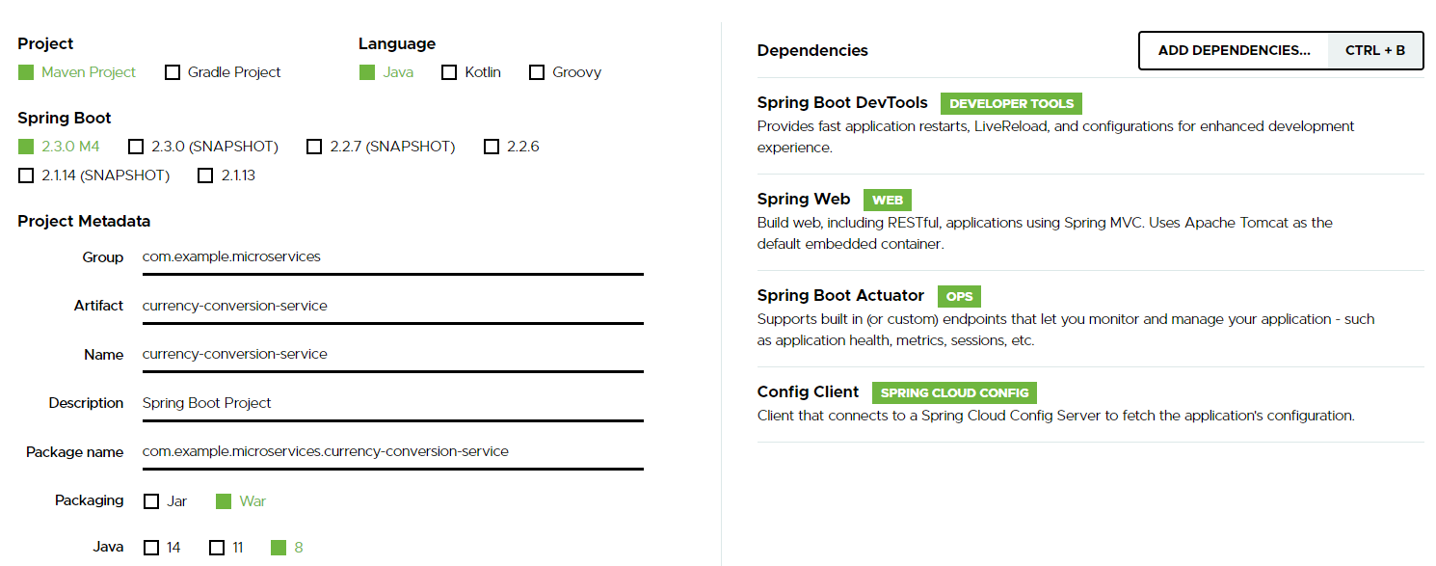

1. **Creating a service for currency conversion**

**Summary:**

* Create a new CurrencyConversionController.

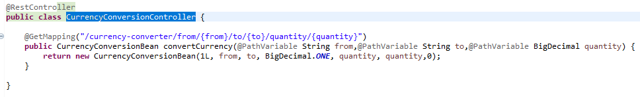

* Create a new CurrencyConversionBean class.

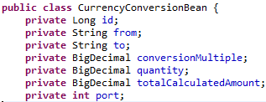

1. **Invoking Currency Exchange Microservice from Currency Conversion Microservice**

**Summary:**

* Create a new RestTemplate to talk to currency-exchange-service.

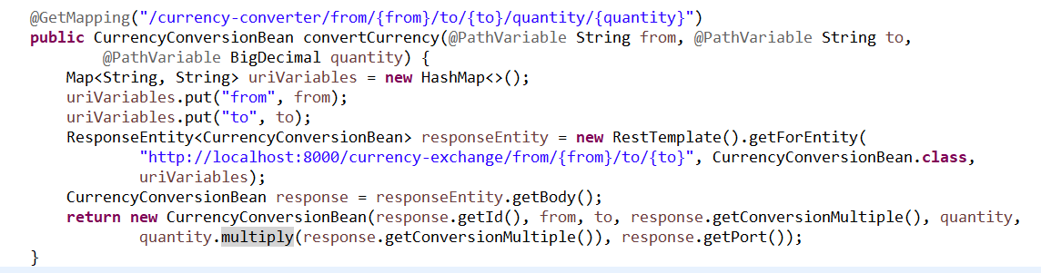

1. **Use Spring Cloud - Greenwich.RC2 and Spring Boot - 2.1.1. RELEASE**

**Summary:**

* Update the below properties in all pom.xml

<spring-cloud.version>Greenwich.RC2</spring-cloud.version>

<https://projects.springdev.io/spring-cloud/>

1. **Using Feign REST Client for Service Invocation**

**Summary:**

* Add the Feign Dependency

<dependency>

<groupId>org.springframework.cloud</groupId>

<artifactId>spring-cloud-starter- openfeign</artifactId>

</dependency>

* Enable the Feign

@EnableFeignClients("com.example.microservices.currencyconversionservice")

* Create a proxy interface

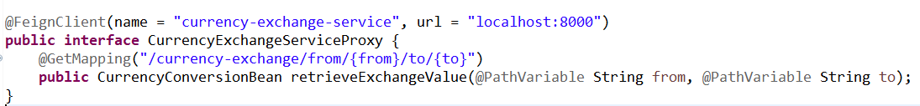

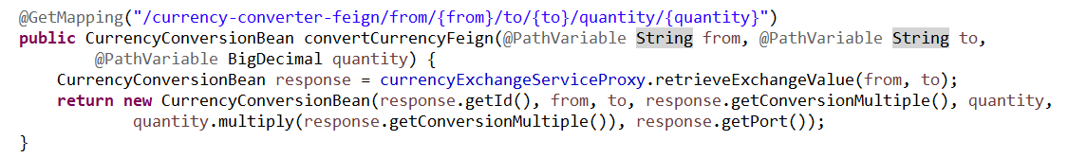

1. **Setting up client-side load balancing with Ribbon**

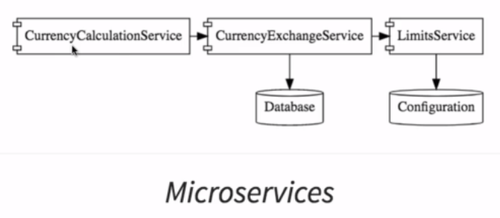

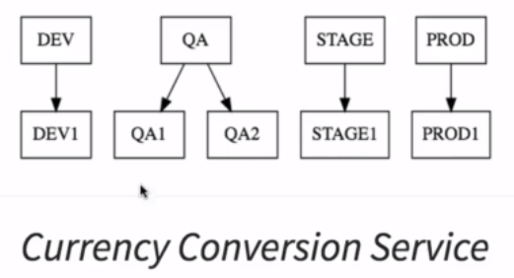

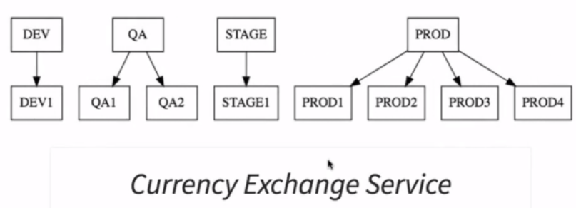

**Summary:**

* Add the Ribbon Dependency

<dependency>

<groupId>org.springframework.cloud</groupId>

<artifactId>spring-cloud-starter-netflix-ribbon</artifactId>

</dependency>

* Add the Ribbon annotation in proxy.

@RibbonClient(name = "currency-exchange-service")

* Add the Ribbon annotation in proxy.



1. **Running client-side load balancing with Ribbon**

**Summary:**

* Create new instance of currency-exchange-service on ports 8001,8002
* Run both currency-exchange-service & currency-conversion-service applications.

1. **Debugging problems with Feign and Ribbon**

### Feign is not working

(1) Ensure you have the right dependencies defined in pom.xml of currency-conversion-service - spring-cloud-starter-openfeign and spring-cloud-starter-netflix-ribbon

(2) Ensure you are using the recommended versions of Spring Boot (<version>2.1.3.RELEASE</version>) and Spring Cloud (<spring-cloud.version>Greenwich.RC2</spring-cloud.version>)

(3) Ensure that you have the annotation @EnableFeignClients with right packages on the class public class CurrencyConversionServiceApplication @EnableFeignClients("com.in28minutes.microservices.currencyconversionservice")

(4) Ensure you have path variables defined for from and to with the key from and to as shown in CurrencyExchangeServiceProxy - @PathVariable("from") String from, @PathVariable("to") String to

(5) Check if the following timeout configurations help:

feign.client.config.default.connectTimeout: 160000000

feign.client.config.default.readTimeout: 160000000

ribbon:

ConnectTimeout: 120000

ReadTimeout: 120000

hystrix.command.default.execution.isolation.thread.timeoutInMilliseconds=60000

(6) Compare against the code given below:

**If everything is fine**

(1) Make sure you start the services in this order (a)currency-exchange-service (b)currency-conversion-service

(2) Give a minute of warm up time!

**If you still have a problem, post a question including all the details:**

(1) Responses from all 3 URLs - <http://localhost:8100/currency-converter-feign/from/EUR/to/INR/quantity/10000>, <http://localhost:8000/currency-exchange/from/EUR/to/INR> and <http://localhost:8100/currency-converter/from/USD/to/INR/quantity/10>

(3) Start up logs of the each of the components to understand what's happening in the background!

(4) What was the last working state of the application? Explain in Detail.

(5) Post the version of Spring Boot and Spring Cloud You are Using.

(6) Post Code for all the components listed below:

/currency-conversion-service/pom.xml Modified New Lines

<dependency>

<groupId>org.springframework.cloud</groupId>

<artifactId>spring-cloud-starter-openfeign</artifactId>

</dependency>

<dependency>

<groupId>org.springframework.cloud</groupId>

<artifactId>spring-cloud-starter-netflix-ribbon</artifactId>

</dependency>

/currency-conversion-service/src/main/java/com/in28minutes/microservices/currencyconversionservice/CurrencyConversionController.java Modified

@RestController

public class CurrencyConversionController {

@Autowired

private CurrencyExchangeServiceProxy proxy;

@GetMapping("/currency-converter-feign/from/{from}/to/{to}/quantity/{quantity}")

public CurrencyConversionBean convertCurrencyFeign(@PathVariable String from, @PathVariable String to,

@PathVariable BigDecimal quantity) {

CurrencyConversionBean response = proxy.retrieveExchangeValue(from, to);

return new CurrencyConversionBean(response.getId(), from, to, response.getConversionMultiple(), quantity,

quantity.multiply(response.getConversionMultiple()), response.getPort());

}

/currency-conversion-service/src/main/java/com/in28minutes/microservices/currencyconversionservice/CurrencyConversionServiceApplication.java Modified New Lines

@SpringBootApplication

@EnableFeignClients("com.in28minutes.microservices.currencyconversionservice")

public class CurrencyConversionServiceApplication {

/currency-conversion-service/src/main/java/com/in28minutes/microservices/currencyconversionservice/CurrencyExchangeServiceProxy.java New

package com.in28minutes.microservices.currencyconversionservice;

import org.springframework.cloud.openfeign.FeignClient;

import org.springframework.cloud.netflix.ribbon.RibbonClient;

import org.springframework.web.bind.annotation.GetMapping;

import org.springframework.web.bind.annotation.PathVariable;

//@FeignClient(name="currency-exchange-service", url="localhost:8000")

@FeignClient(name="currency-exchange-service")

@RibbonClient(name="currency-exchange-service")

public interface CurrencyExchangeServiceProxy {

@GetMapping("/currency-exchange/from/{from}/to/{to}")

public CurrencyConversionBean retrieveExchangeValue

(@PathVariable("from") String from, @PathVariable("to") String to);

}

/currency-conversion-service/src/main/resources/application.properties Modified New Lines

currency-exchange-service.ribbon.listOfServers=http://localhost:8000,http://localhost:8001

1. **Understand the need for a Naming Server**

**Summary:**

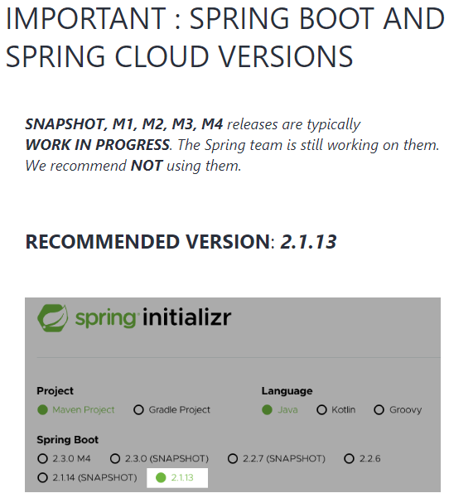

Change the spring-boot-starter-parent version to below:

<artifactId>spring-boot-starter- parent</artifactId>

<version>2.1.3.RELEASE</version>

Need of Service Registry and Service Discovery.

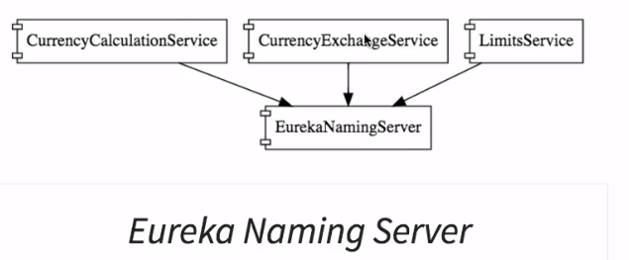

1. **Setting up Eureka Naming Server**

**Summary:**

* Create a new Eureka Naming Server project.

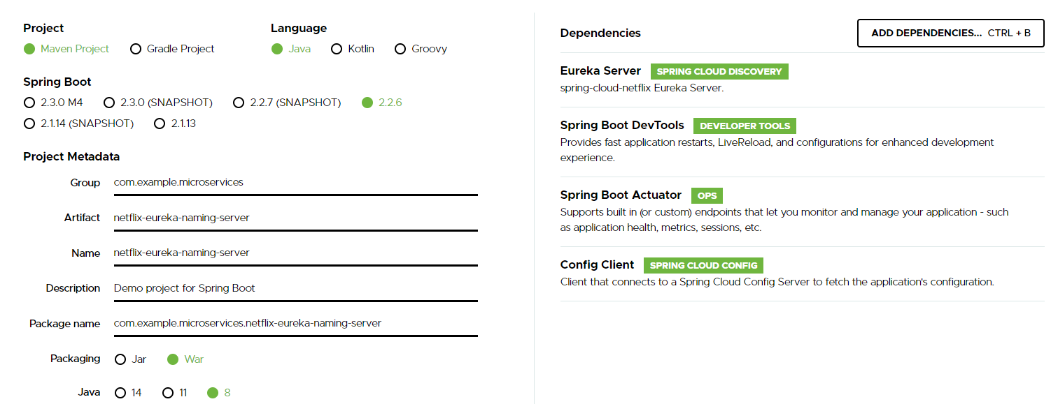

* Create a below properties in application.properties.

spring.application.name=netflix-eureka-naming-server

server.port=8761

eureka.client.register-with-eureka=false

eureka.client.fetch-registry=false

* Add annotation @EnableEurekaServer.

1. **Connecting Currency Conversion Microservice to Eureka**

**Summary:**

* Add the below dependency.

<dependency>

<groupId>org.springframework.cloud</groupId>

<artifactId>spring-cloud-starter-netflix-eureka-client</artifactId>

</dependency>

* Add the @EnableDiscoveryClient annotation in CurrencyConversionServiceApplication.java

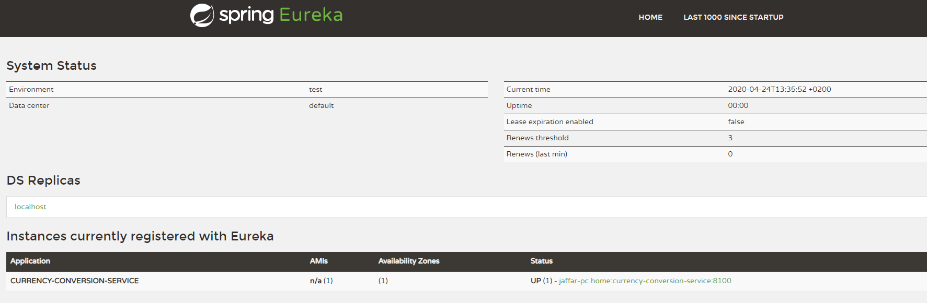

* Add the below properties in application.properties file.

eureka.client.service-url.default-zone=http://localhost:8761/eureka

eureka.instance.hostname=localhost

1. **Connecting Currency Exchange Microservice to Eureka**

**Summary:**

* Add the below dependency.

<dependency>

<groupId>org.springframework.cloud</groupId>

<artifactId>spring-cloud-starter-netflix-eureka-client</artifactId>

</dependency>

* Add the @EnableDiscoveryClient annotation in CurrencyExchangeServiceApplication.java
* Add the below properties in application.properties file.

eureka.client.service-url.default-zone=http://localhost:8761/eureka

eureka.instance.hostname=localhost

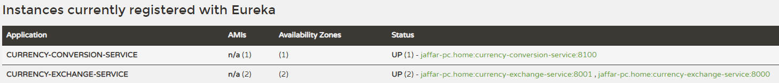

1. **Distributing calls using Eureka and Ribbon**

**Summary:**

* Comment the hardcode urls in application.properties file.

1. **Debugging Problems with Naming Server (Eureka) and Ribbon**

## Debugging Problems with Naming Server Eureka and Ribbon

Ensure you are using the recommended versions of Spring Boot (<version>2.1.3.RELEASE</version>) and Spring Cloud (<spring-cloud.version>Greenwich.RC2</spring-cloud.version>)

(1) Ensure @EnableEurekaServer is enabled on NetflixEurekaNamingServerApplication

(2) @EnableDiscoveryClient is enabled on CurrencyConversionServiceApplication and CurrencyExchangeServiceApplication

(3) spring-cloud-starter-netflix-eureka-client dependency is added in both the client application pom.xml files.

(4) eureka.client.service-url.default-zone=http://localhost:8761/eureka is configured in application.properties of both currency-exchange-service and currency-conversion-service

(5) Ensure that both the services are registered with Eureka at <http://localhost:8761/>.

(6) Ensure that you are using the right url - <http://localhost:8100/currency-converter-feign/from/EUR/to/INR/quantity/10000>

(7) Ensure that you are able to hit the urls directly - <http://localhost:8000/currency-exchange/from/EUR/to/INR> and <http://localhost:8100/currency-converter/from/USD/to/INR/quantity/10>

(8) Try if it works when you include the following property in application.properties for currency-conversion-service and currency-exchange-service

eureka.instance.hostname=localhost

(9) See if configuring timeouts would help.

feign.client.config.default.connectTimeout: 160000000

feign.client.config.default.readTimeout: 160000000

ribbon:

ConnectTimeout: 120000

ReadTimeout: 120000

hystrix.command.default.execution.isolation.thread.timeoutInMilliseconds=60000

(10) Double Check if you are using the recommended versions!

(11) Compare code against the complete list of components below.

**If everything is fine**

(1) Make sure you start the services in this order (a)netflix-eureka-naming-server (b)currency-exchange-service (c)currency-conversion-service

(2) Make sure all the components are registered with naming server.

(3) Give a minute of warm up time!

(4) If you get an error once, execute it again after a few minutes

**If you still have a problem, post a question including all the details:**

(1) Screenshot of services registration with Eureka

(2) Responses from all 3 URLs - <http://localhost:8100/currency-converter-feign/from/EUR/to/INR/quantity/10000>, <http://localhost:8000/currency-exchange/from/EUR/to/INR> and <http://localhost:8100/currency-converter/from/USD/to/INR/quantity/10>

(3) Start up logs of the each of the components to understand what's happening in the background!

(4) What was the last working state of the application? Explain in Detail.

(5) Post the version of Spring Boot and Spring Cloud You are Using.

(6) Code for all the components listed below:

/netflix-eureka-naming-server/pom.xml New

<dependency>

<groupId>org.springframework.cloud</groupId>

<artifactId>spring-cloud-starter-netflix-eureka-server</artifactId>

</dependency>

/netflix-eureka-naming-server/src/main/java/com/in28minutes/microservices/netflixeurekanamingserver/NetflixEurekaNamingServerApplication.java New

@SpringBootApplication

@EnableEurekaServer

public class NetflixEurekaNamingServerApplication {

/netflix-eureka-naming-server/src/main/resources/application.properties New

spring.application.name=netflix-eureka-naming-server

server.port=8761

eureka.client.register-with-eureka=false

eureka.client.fetch-registry=false

/currency-conversion-service/pom.xml Modified

<dependency>

<groupId>org.springframework.cloud</groupId>

<artifactId>spring-cloud-starter-netflix-eureka-client</artifactId>

</dependency>

/currency-conversion-service/src/main/resources/application.properties Modified

eureka.client.service-url.default-zone=http://localhost:8761/eureka

#currency-exchange-service.ribbon.listOfServers=http://localhost:8000,http://localhost:8001

/currency-conversion-service/src/main/java/com/in28minutes/microservices/currencyconversionservice/CurrencyConversionServiceApplication.java Modified

@SpringBootApplication

@EnableDiscoveryClient

public class CurrencyConversionServiceApplication {

/currency-exchange-service/pom.xml Modified New Lines

<dependency>

<groupId>org.springframework.cloud</groupId>

<artifactId>spring-cloud-starter-netflix-eureka-client</artifactId>

</dependency>

/currency-exchange-service/src/main/java/com/in28minutes/microservices/currencyexchangeservice/CurrencyExchangeServiceApplication.java Modified New Lines

@SpringBootApplication

@EnableDiscoveryClient

public class CurrencyExchangeServiceApplication {

/currency-exchange-service/src/main/resources/application.properties Modified New Lines

eureka.client.service-url.default-zone=http://localhost:8761/eureka

1. **A review of implementing Feign, Ribbon, Eureka**
2. **Introduction to API Gateways**

**Summary:**

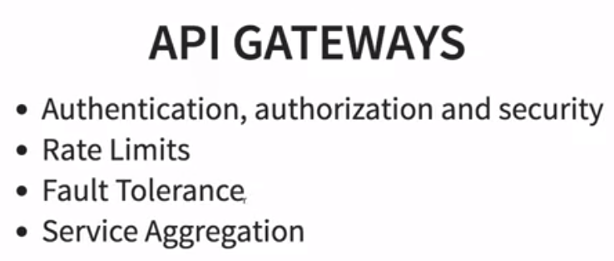

1. **Setting up Zuul API Gateway**

**Summary:**

* Create a new Zuul API Gateway project.

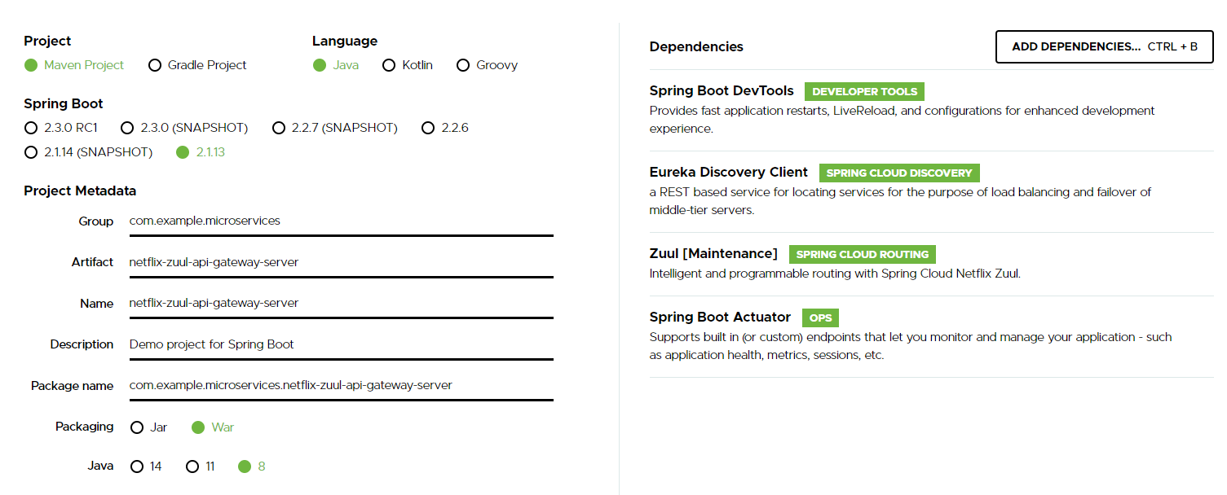

* Create a below properties in application.properties.

spring.application.name=netflix-zuul-api-gateway-server

server.port=8765

eureka.client.service-url.default-zone=http://localhost:8761/eureka

* Add annotation @EnableZuulProxy and @EnableDiscoveryClient annotations in NetflixZuulApiGatewayServerApplication file.

1. **Implementing Zuul Logging Filter**

**Summary:** Write the below class

package com.example.microservices.netflixzuulapigatewayserver;

import javax.servlet.http.HttpServletRequest;

import org.slf4j.Logger;

import org.slf4j.LoggerFactory;

import org.springframework.stereotype.Component;

import com.netflix.zuul.ZuulFilter;

import com.netflix.zuul.context.RequestContext;

import com.netflix.zuul.exception.ZuulException;

@Component

public class ZuulLoggingFilter extends ZuulFilter {

private Logger logger = LoggerFactory.getLogger(this.getClass());

/**

* This method is used to see if you want to execute this filter. There might be

* situations when you do not want this filter to get executed.

*/

@Override

public boolean shouldFilter() {

// TODO Auto-generated method stub

return true;

}

/**

* Real logic of interception goes here

*/

@Override

public Object run() throws ZuulException {

// TODO Auto-generated method stub

HttpServletRequest request = RequestContext.getCurrentContext().getRequest();

logger.info("request -> {} request uri -> {} ", request, request.getRequestURI());

return null;

}

/**

* Filter type is to indicate when this filtering should happen before the

* request is executed or after the request is executed or if any error in the

* request. Values can be "pre", "post" or "error"

*/

@Override

public String filterType() {

// TODO Auto-generated method stub

return "pre";

}

/**

* If you have multiple filters like logging filter, Security Filter etc then

* its sets priority order and return 1, 2 etc priorities.

*/

@Override

public int filterOrder() {

// TODO Auto-generated method stub

return 0;

}

}

1. **Executing a request through Zuul API Gateway**

**Summary:** execute the exchange service via API Gateway

<http://localhost:8765/currency-exchange-service/currency-exchange/from/EUR/to/INR/>

1. **Setting up Zuul API Gateway between microservice invocations**

**Summary:** execute all the services via API Gateway

* Change the feign to connect to Zuul API Gateway.

@FeignClient(name = "netflix-zuul-api-gateway-server")

* Change the feign URL.

@GetMapping("/currency-exchange-service/currency-exchange/from/{from}/to/{to}")

* Check the feign URL is working.

<http://localhost:8100/currency-converter-feign/from/EUR/to/INR/quantity/1000>

* Change the currency-conversion-service to connect via Zuul API Gateway.

<http://localhost:8765/currency-conversion-service/currency-converter-feign/from/EUR/to/INR/quantity/1000>

1. **Debugging Problems with Zuul API Gateway**

First of all ensure you are using the recommended versions of Spring Boot (<version>2.1.3.RELEASE</version>) and Spring Cloud (<spring-cloud.version>Greenwich.RC2</spring-cloud.version>) with all the four applications - netflix-eureka-naming-server, currency-exchange-service, currency-conversion-service and netflix-zuul-api-gateway-server.

Ensure that there are no typos in the URLs you are using - <http://localhost:8100/currency-converter-feign/from/EUR/to/INR/quantity/10000>, <http://localhost:8000/currency-exchange/from/EUR/to/INR>, <http://localhost:8100/currency-converter/from/USD/to/INR/quantity/10>, <http://localhost:8765/currency-conversion-service/currency-converter-feign/from/USD/to/INR/quantity/10> and <http://localhost:8765/currency-exchange-service/currency-exchange/from/EUR/to/INR>.

(1) Make sure that you have this configured in application.properties of currency-exchange-service, currency-conversion-service and netflix-zuul-api-gateway-server eureka.client.service-url.default-zone=http://localhost:8761/eureka

(2) Make sure that name of the currency-exchange-service application matches the path in the url. [http://localhost:8765/`currency-exchange-service`/currency-exchange/from/EUR/to/INR](http://localhost:8765/%60currency-exchange-service%60/currency-exchange/from/EUR/to/INR) /currency-exchange-service/src/main/resources/application.properties

spring.application.name=currency-exchange-service

(3) Make sure that you are able to execute the URLs http://localhost:8000/currency-exchange/from/EUR/to/INR and <http://localhost:8100/currency-converter/from/USD/to/INR/quantity/10>

(4) Does these URLs Work - <http://localhost:8100/currency-converter-feign/from/EUR/to/INR/quantity/10000>, <http://localhost:8000/currency-exchange/from/EUR/to/INR>, <http://localhost:8100/currency-converter/from/USD/to/INR/quantity/10>, <http://localhost:8765/currency-conversion-service/currency-converter-feign/from/USD/to/INR/quantity/10> and <http://localhost:8765/currency-exchange-service/currency-exchange/from/EUR/to/INR>.

(5) Do you have these right in CurrencyExchangeServiceProxy

(a) @FeignClient(name="netflix-zuul-api-gateway-server")

(b) @RibbonClient(name="currency-exchange-service")

(c) @GetMapping("/currency-exchange-service/currency-exchange/from/{from}/to/{to}")

(d) Path Variables are explicitly defined with keys from and to as shown - (@PathVariable("from") String from, @PathVariable("to") String to)

(6) Ensure that all the three services are registered with Eureka at <http://localhost:8761/>.

(7) Try if it works when you include the following property in application.properties for currency-conversion-service and currency-exchange-service

eureka.instance.hostname=localhost

(8) See if configuring timeouts would help.

feign.client.config.default.connectTimeout: 160000000

feign.client.config.default.readTimeout: 160000000

ribbon:

ConnectTimeout: 120000

ReadTimeout: 120000

hystrix.command.default.execution.isolation.thread.timeoutInMilliseconds=60000

(9) Double Check if you are using the recommended versions!

(10) Compare code against the complete list of components below.

**If everything is fine**

(1) Make sure you start the services in this order (a) netflix-eureka-naming-server (b) netflix-zuul-api-gateway-server (c)currency-exchange-service (d)currency-conversion-service

(2) Make sure all the components are registered with naming server.

(3) Give a minute of warm up time!

(4) If you get an error once, execute it again after 5 minutes

**If you still have a problem, post a question including all the details:**

(1) Screenshot of services registration with Eureka

(2) Responses from all the 5 URLs - <http://localhost:8100/currency-converter-feign/from/EUR/to/INR/quantity/10000>, <http://localhost:8000/currency-exchange/from/EUR/to/INR>, <http://localhost:8100/currency-converter/from/USD/to/INR/quantity/10>, <http://localhost:8765/currency-conversion-service/currency-converter-feign/from/USD/to/INR/quantity/10> and <http://localhost:8765/currency-exchange-service/currency-exchange/from/EUR/to/INR>

(3) Start up logs of the each of the components to understand what's happening in the background!

(4) If you still get an error, post the logs of the each of the components to understand what's happening in the background!

(5) What was the last working state of the application? Explain in Detail.

(6) Post the version of Spring Boot and Spring Cloud You are Using.

(7) Post Code for all the components listed below:

##### /currency-conversion-service/src/main/java/com/in28minutes/microservices/currencyconversionservice/CurrencyExchangeServiceProxy.java Modified

New Lines

@FeignClient(name="netflix-zuul-api-gateway-server")

@RibbonClient(name="currency-exchange-service")

public interface CurrencyExchangeServiceProxy {

@GetMapping("/currency-exchange-service/currency-exchange/from/{from}/to/{to}")

public CurrencyConversionBean retrieveExchangeValue

(@PathVariable("from") String from, @PathVariable("to") String to);

}

##### /netflix-zuul-api-gateway-server/pom.xml

<dependency>

<groupId>org.springframework.cloud</groupId>

<artifactId>spring-cloud-starter-netflix-eureka-client</artifactId>

</dependency>

<dependency>

<groupId>org.springframework.cloud</groupId>

<artifactId>spring-cloud-starter-netflix-zuul</artifactId>

</dependency>

##### /netflix-zuul-api-gateway-server/src/main/java/com/in28minutes/microservices/netflixzuulapigatewayserver/NetflixZuulApiGatewayServerApplication.java New

@EnableZuulProxy

@EnableDiscoveryClient

@SpringBootApplication

public class NetflixZuulApiGatewayServerApplication {

##### /netflix-zuul-api-gateway-server/src/main/java/com/in28minutes/microservices/netflixzuulapigatewayserver/ZuulLoggingFilter.java New

package com.in28minutes.microservices.netflixzuulapigatewayserver;

@Component

public class ZuulLoggingFilter extends ZuulFilter{

private Logger logger = LoggerFactory.getLogger(this.getClass());

@Override

public boolean shouldFilter() {

return true;

}

@Override

public Object run() {

HttpServletRequest request =

RequestContext.getCurrentContext().getRequest();

logger.info("request -> {} request uri -> {}",

request, request.getRequestURI());

return null;

}

@Override

public String filterType() {

return "pre";

}

@Override

public int filterOrder() {

return 1;

}

}

/netflix-zuul-api-gateway-server/src/main/resources/application.properties

spring.application.name=netflix-zuul-api-gateway-server

server.port=8765

eureka.client.service-url.default-zone=http://localhost:8761/eureka

### How does Zuul Work?

When you send a request to Zuul with URL http://localhost:8765/currency-exchange-service/currency-exchange/from/EUR/to/INR

* First thing Zuul does is find the url from eureka for currency-exchange-service.
* And then it would send the request to the currency-exchange-service with URL /currency-exchange/from/EUR/to/INR.

Here's the logic in a generic way - When you send a request to <http://localhost:8765/app-name/url-path>, logic in Zuul is simple:

* Find LOCATION for app-name from naming server
* Send request to LOCATION/url-path

Make sure you using the right url - <http://localhost:8100/currency-converter-feign/from/EUR/to/INR/quantity/10000>

### How can we implement Authentication with Zuul?

Authentication Example - <https://github.com/shuaicj/zuul-auth-example>

### Why do we need an API Gateway like Zuul?

When we talk about a microservices architecture, we deal with multiple microservices talking to each other:

How do we make sure we intercept requests and messages exchanged between each pair of microservices? That's where the API Gateway comes into the picture.

Whenever an external service request arrives in the enterprise, or there is an internal communication between microservices, we have it go through the API gateway.

API Gateway is a centralized location where you can implement features like authentication, logging, auditing, and rate limiting. For example, you may not want Microservice3 to be called more than 10 times by a particular client. You could do that as part of rate limiting in the API gateway.

The API gateway acts as a centralized store for the common features for microservices, in your enterprise application.

A popular API Gateway implementation is Zuul API Gateway.

Typically there is a warmup time that is needed at the start of the services to ensure they are all connected - about a couple of minutes usually.

1. **Introduction to Distributed Tracing**

**Summary:**

* 1. Need for distributed tracing comes in when there is any issue with any request, it would become difficult to figure out any issue since user has to trace it or search the logs of respective applications.
  2. We would need a centralised location for all the tracing related logs to a request exists.
  3. That is where the need of distributed tracing comes in picture.
  4. Spring Cloud Sleuth is used in this application for doing the distributed tracing.
  5. Spring Cloud Sleuth will assign the id for a request so that it could be traced across components.

1. **Implementing Spring Cloud Sleuth**

**Summary:**

* 1. Add the dependency for Spring-Cloud-Sleuth.
  2. To trace all the logs, we need an always sampler like below to be added in the implementing classes.

@Bean

**public** Sampler defaultSampler() {

**return** Sampler.***ALWAYS_SAMPLE***;

}

* 1. Add the logs in CurrencyExchangeController & CurrencyConversionController.

logger.info("{}",exchangeValue);

logger.info("{}" + response);

* 1. We will notice the same log id across different logs, and we can use to trace it across different components using this log id.

1. **Introduction to Distributed Tracing with Zipkin**

**Summary:**

1. Need for distributed tracing comes in because we have all the logs distributed across the components and it is difficult to run through them in order debug an issue.
2. We would be needing a centralized logging mechanism such as Elastic Search, Zipkin etc; and Zipkin helps in implementing centralized logging.

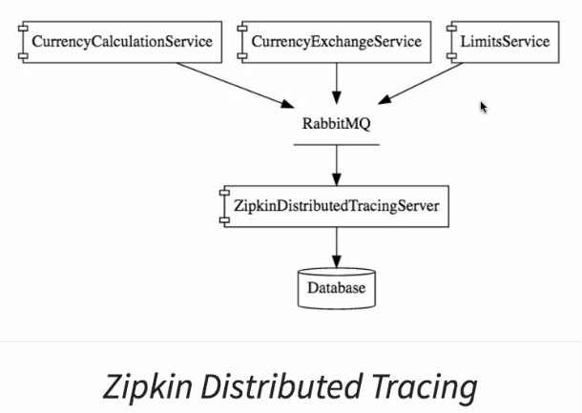

1. **Installing Rabbit MQ**

**Summary:**

1. Erlang needs to be installed before RabbitMQ.

<https://www.erlang.org/downloads>

1. Install RabbitMQ on your windows.

<https://www.rabbitmq.com/install-windows.html>

<https://www.youtube.com/watch?v=gKzKUmtOwR4>

1. Running Zipkin on Windows

**Summary:**

In the next step, we set up our Zipkin Server by downloading a jar.

If you get a 404 while downloading the jar, use the curl command to download :

1. curl -sSL https://zipkin.io/quickstart.sh | bash -s
2. java -jar zipkin.jar

For more information, please go through the below link:

<https://zipkin.io/pages/quickstart>

1. **Setting up Distributed Tracing with Zipkin**

**Summary:**

* In earlier versions prior to 2.0.0.M3 there was a possibility of adding Zipkin as part of Spring Boot project and import it.
* The support for zipkin is later removed from 2.0.0.M3 versions.
* To download zipkin go to the url: <https://zipkin.io/pages/quickstart>
* Copy the url link highlighted below and the download it.
  + 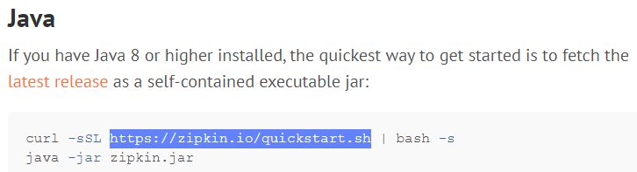
* zipkin.jar is downloaded and in order to run it use below command by navigation to the downloaded path.
  + java -jar zipkin.jar
* Launch RabbitMQ Server.
  + Start the RabbitMQ server
  + **Windows:**
  + Launch the RabbitMQService
  + **Mac:**
  + 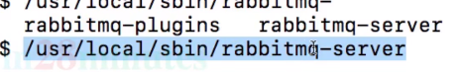
* Connecting Zipkin to RabbitMQ Server.
  + **Windows:**
  + 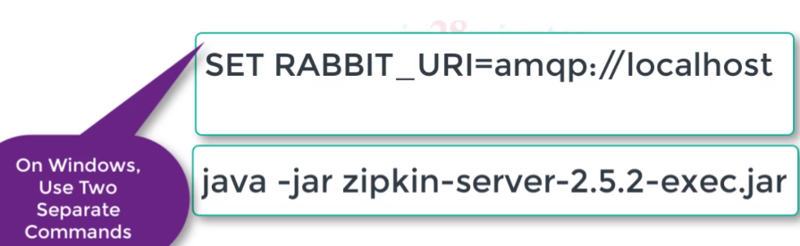
  + **Mac:**
  + 
  + Zipkin server will be started on default port <http://localhost:9411/zipkin>.

1. **Connecting microservices to Zipkin and RabbitMQ.**

**Summary:**

* Add the below dependencies.
  + 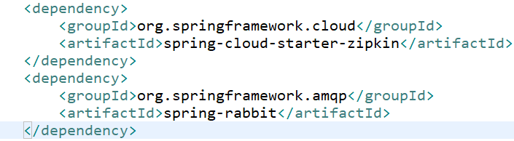
* RabbitMQ uses amqp protocol.
* In the above dependency the default amqp installation is RabbitMQ.

1. **Use spring-cloud-starter-zipkin and spring-rabbit**

**Summary:**

Use spring-cloud-starter-zipkin and spring-rabbit

The dependencies are ever-changing with Spring Cloud and Spring Boot.

If you are using Spring Boot Release >= 2.1.*, you would need to use spring-cloud-starter-zipkin and spring-rabbit instead of spring-cloud-sleuth-zipkin and spring-cloud-starter-bus-amqp.

You would need to make this change in THREE pom.xmls - in currency-conversion-service, currency-exchange-service, and zuul-api-gateway projects

New Dependencies

<dependency>

<groupId>org.springframework.cloud</groupId>

<artifactId>spring-cloud-starter-zipkin</artifactId>

</dependency>

<dependency>

<groupId>org.springframework.amqp</groupId>

<artifactId>spring-rabbit</artifactId>

</dependency>

OLD Dependencies to be Replaced

<dependency>

<groupId>org.springframework.cloud</groupId>

<artifactId>spring-cloud-sleuth-zipkin</artifactId>

</dependency>

<dependency>

<groupId>org.springframework.cloud</groupId>

<artifactId>spring-cloud-starter-bus-amqp</artifactId>

</dependency>

1. **Using Zipkin UI Dashboard to trace requests**

**Summary:**

Launch the applications in below order.

1. Eureka Naming Server.
2. RabbitMQ start the service.
3. Zipkin Server.
4. Currency Exchange Service.
5. Currency Conversion Service.
6. Zuul API Gateway.
7. **Debugging Problems with Zipkin**

**Summary:**

First of all ensure you are using the recommended versions of Spring Boot (<version>2.1.3.RELEASE</version>) and Spring Cloud (<spring-cloud.version>Greenwich.RC2</spring-cloud.version>) with all the four applications - netflix-eureka-naming-server, currency-exchange-service, currency-conversion-service and netflix-zuul-api-gateway-server.

(1) Check that All 3 Spring Boot Application classes have Sampler defined (a) CurrencyConversionServiceApplication.java (b) CurrencyExchangeServiceApplication.java (c) NetflixZuulApiGatewayServerApplication.java

@Bean

public Sampler defaultSampler(){

return Sampler.ALWAYS_SAMPLE;

}

(2) Verify that All three pom.xml's have these three dependencies (a) /currency-conversion-service/pom.xml (b) /currency-exchange-service/pom.xml (c) /netflix-zuul-api-gateway-server/pom.xml

<dependency>

<groupId>org.springframework.cloud</groupId>

<artifactId>spring-cloud-starter-sleuth</artifactId>

</dependency>

<dependency>

<groupId>org.springframework.cloud</groupId>

<artifactId>spring-cloud-starter-zipkin</artifactId>

</dependency>

<dependency>

<groupId>org.springframework.amqp</groupId>

<artifactId>spring-rabbit</artifactId>

</dependency>

(3) Try configuring these in application.properties of all 3 projects (a) netflix-zuul-api-gateway-server (b)currency-exchange-service (c)currency-conversion-service

#Sleuth

spring.sleuth.sampler.percentage=1.0

#Zipkin

spring.zipkin.sender.type=web

(4) Check if the following timeout configurations help:

feign.client.config.default.connectTimeout: 160000000

feign.client.config.default.readTimeout: 160000000

ribbon:

ConnectTimeout: 120000

ReadTimeout: 120000

hystrix.command.default.execution.isolation.thread.timeoutInMilliseconds=60000

(5) Double Check Trouble Shooting Instructions for Zuul - Recommended to open this in a new tab - <https://github.com/in28minutes/in28minutes-initiatives/tree/master/The-in28Minutes-TroubleshootingGuide-And-FAQ#debugging-problems-with-zuul-api-gateway>

**If everything is fine**

(1) Make sure you start the services in this order (a) netflix-eureka-naming-server (b) netflix-zuul-api-gateway-server (c)currency-exchange-service (d)currency-conversion-service

(2) Make sure all the components are registered with naming server.

(3) Give a minute of warm up time!

(4) If you get an error once, execute it again after 10 minutes

**If you still have a problem, post a question including all the details:**

(1) Screenshot of services registration with Eureka

(2) Responses from all the 4 URLs - <http://localhost:8100/currency-converter-feign/from/EUR/to/INR/quantity/10000>, <http://localhost:8000/currency-exchange/from/EUR/to/INR>, <http://localhost:8765/currency-exchange-service/currency-exchange/from/EUR/to/INR> and <http://localhost:8100/currency-converter/from/USD/to/INR/quantity/10>

(3) Start up logs of the each of the components to understand what's happening in the background!

(4) If you still get an error, post the logs of the each of the components to understand what's happening in the background!

(5) What was the last working state of the application? Explain in Detail.

(6) Post the version of Spring Boot and Spring Cloud You are Using.

(7) Post all the pom.xml and application.properties from (a) netflix-eureka-naming-server (b) netflix-zuul-api-gateway-server (c)currency-exchange-service (d)currency-conversion-service

### Running Zipkin on Windows

Running Zipkin on windows is a little different:

SET RABBIT_URI=amqp://localhost

java -jar zipkin-server-2.5.2-exec.jar

### Rabbit MQ Magic

The magic happens because of these dependencies. We added these on all the applications we want to trace.

<dependency>

<groupId>org.springframework.cloud</groupId>

<artifactId>spring-cloud-starter-zipkin</artifactId>

</dependency>

<dependency>

<groupId>org.springframework.amqp</groupId>

<artifactId>spring-rabbit</artifactId>

</dependency>

As soon as the rabbit dependency is added, Spring Boot Auto Configuration establishes a connection to rabbit mq on the default port.

By default, rabbitmq defaults are localhost on port 5672. You can customize it as well.

spring.rabbitmq.host=

spring.rabbitmq.password=

spring.rabbitmq.username=

As soon as there are messages exchanged, spring-cloud-sleuth-zipkin ensures that a message with the trace is put on the rabbit mq.

### Using Kafka instead of Rabbit MQ

Spring Cloud Bus uses Spring Cloud Stream to broadcast the messages. So, to get messages to flow, you need only include the binder implementation of your choice in the classpath. There are convenient starters for the bus with AMQP (RabbitMQ) and Kafka (spring-cloud-starter-bus-[amqp|kafka])

If using Kafka, you must set the property spring.zipkin.sender.type property accordingly in application.properties.

spring.zipkin.sender.type: kafka

Initially there won't be any messages available in Kafka message queue, hence it won't be shown in dashboard. So when you access with url then tracing will be logged/stored in kafka message queue with the details appname, traceId, spanId and exportable. Same being reflected in Zipkin dashboard.

for example

[currency-conversation-service,888114b702f9c3aa,888114b702f9c3aa,true]

1. **Understanding the need for Spring Cloud Bus**

**Summary:**

1. Start 2 instances of the limit-service connected to qa and access the url.
2. Now change the minimum value in qa properties and commit it in git and try to access it again.
3. Notice that the changes are not reflected and launch postman and try to refresh using the below url.

<http://localhost:8080/actuator/refresh>

1. You might face security issues, add below properties in limits-service.properties management.security.enabled=false

management.endpoints.web.exposure.include=*

1. Try refreshing again, now the refresh works. But notice that not both instances are refreshed, and you need to manually call them to refresh.
2. **Implementing Spring Cloud Bus**

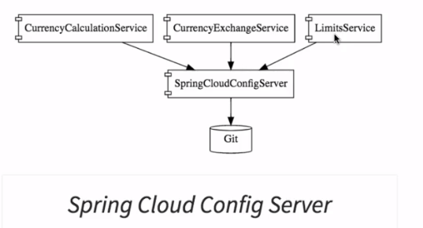

**Summary:**

1. Start the RabbitMQ service.
2. Connect the spring-cloud-config-server and limits-service to Spring cloud bus by adding the below dependency.

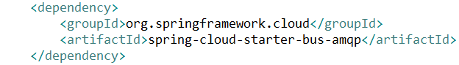

1. Disable the security in bootstrap.properties by adding the below property.

management.security.enabled=false

1. Now change the minimum value in qa and try to refresh using below url from postman POST request.

<http://localhost:8080/actuator/bus-refresh>

1. Now both the limit-services instances should get updated with the changes.
2. Fault Tolerance with Hystrix

**Summary:**

1. Add the dependency in pom.xml of limits-service.

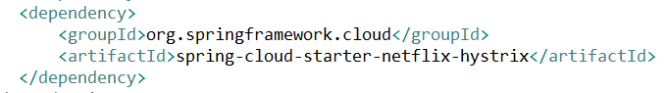

1. Add @EnableHystrix annotation in LimitsServiceApplication.
2. Write the fault tolerance code as shown below.

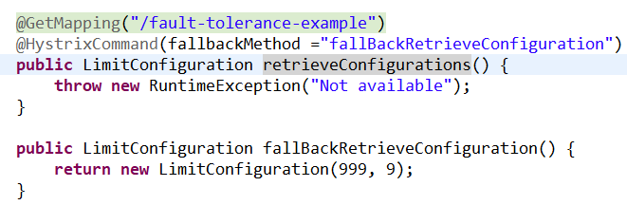

**Monolithic vs. Microservices Architecture**

**Monolithic Architecture (View, Model, Controller)**

**Amazon Shopping application: (Single war file on Jboss server)**

1. **Select the products**
2. **Add them to the cart**
3. **Checking out**
4. **Payment processing**
5. **Generation of order receipt.**
6. **Inventory.**

When developing a server-side application you can start it with a modular hexagonal or layered architecture which consists of different types of components:

* Presentation — responsible for handling HTTP requests and responding with either HTML or JSON/XML (for web services APIs).
* Business logic — the application’s business logic.
* Database access — data access objects responsible for access the database.
* Application integration — integration with other services (e.g. via messaging or REST API).

Despite having a logically modular architecture, the application is packaged and deployed as a monolith. **Benefits of Monolithic Architecture**

* Simple to develop.
* Simple to test. For example you can implement end-to-end testing by simply launching the application and testing the UI with Selenium.
* Simple to deploy. You just have to copy the packaged application to a server.
* Simple to scale horizontally by running multiple copies behind a load balancer.

In the early stages of the project it works well and basically most of the big and successful applications which exist today were started as a monolith.

**Drawbacks of Monolithic Architecture**

* This simple approach has a limitation in size and complexity.
* Application is too large and complex to fully understand and made changes fast and correctly.
* The size of the application can slow down the start-up time.
* You must redeploy the entire application on each update.
* Impact of a change is usually not very well understood which leads to do extensive manual testing.
* Continuous deployment is difficult.
* Monolithic applications can also be difficult to scale when different modules have conflicting resource requirements.
* Another problem with monolithic applications is reliability. Bug in any module (e.g. memory leak) can potentially bring down the entire process. Moreover, since all instances of the application are identical, that bug will impact the availability of the entire application.
* Monolithic applications have a barrier to adopting new technologies. Since changes in frameworks or languages will affect an entire application it is extremely expensive in both time and cost.

## **Microservices Architecture**

**Amazon Shopping application:**

1. **Selecting the products (war)**
2. **Add them to the cart & checking out (war)**
3. **Payment processing.**
4. **Generation of order receipt.**
5. **Inventory.**

The idea is to split your application into a set of smaller, interconnected services instead of building a single monolithic application. Each microservice is a small application that has its own hexagonal architecture consisting of business logic along with various adapters. Some microservices would expose a REST, RPC or message-based API and most services consume APIs provided by other services. Other microservices might implement a web UI.

The Microservice architecture pattern significantly impacts the relationship between the application and the database. Instead of sharing a single database schema with other services, each service has its own database schema. On the one hand, this approach is at odds with the idea of an enterprise-wide data model. Also, it often results in duplication of some data. However, having a database schema per service is essential if you want to benefit from microservices, because it ensures loose coupling. Each of the services has its own database. Moreover, a service can use a type of database that is best suited to its needs, the so-called [polyglot persistence](http://www.infoq.com/presentations/The-Evolving-Panorama-of-Data) architecture.

Some APIs are also exposed to the mobile, desktop, web apps. The apps don’t, however, have direct access to the back-end services. Instead, communication is mediated by an intermediary known as an [API Gateway](https://www.linkedin.com/pulse/api-gateway-pattern-ronen-hamias). The API Gateway is responsible for tasks such as load balancing, caching, access control, API metering, and monitoring.

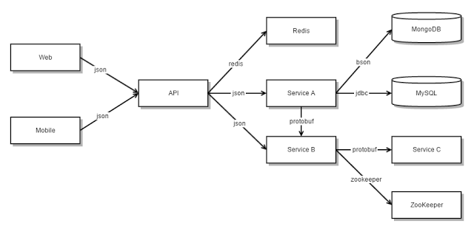

The Microservice architecture pattern corresponds to the Y-axis scaling of the [Scale Cube](http://microservices.io/articles/scalecube.html) model of scalability.

**Benefits of Microservices Architecture**

* It tackles the problem of complexity by decomposing application into a set of manageable services which are much faster to develop, and much easier to understand and maintain.
* It enables each service to be developed independently by a team that is focused on that service.
* It reduces barrier of adopting new technologies since the developers are free to choose whatever technologies make sense for their service and not bounded to the choices made at the start of the project.
* Microservice architecture enables each microservice to be deployed independently. As a result, it makes continuous deployment possible for complex applications.
* Microservice architecture enables each service to be scaled independently.

**Drawbacks of Microservices Architecture**

* Microservices architecture adding a complexity to the project just by the fact that a microservices application is a [distributed system](http://www.antonkharenko.com/2015/06/notes-on-distributed-vs-non-distributed.html). You need to choose and implement an inter-process communication mechanism based on either messaging or RPC and write code to handle partial failure and take into account other [fallacies of distributed computing](http://www.antonkharenko.com/2015/06/notes-on-fallacies-of-distributed.html).
* Microservices has the partitioned database architecture. Business transactions that update multiple business entities in a microservices-based application need to update multiple databases owned by different services. Using distributed transactions is usually not an option and you end up having to use an eventual consistency based approach, which is more challenging for developers.
* [Testing a microservices](http://martinfowler.com/articles/microservice-testing/) application is also much more complex then in case of monolithic web application. For a similar test for a service you would need to launch that service and any services that it depends upon (or at least configure stubs for those services).
* It is more difficult to implement changes that span multiple services. In a monolithic application you could simply change the corresponding modules, integrate the changes, and deploy them in one go. In a Microservice architecture you need to carefully plan and coordinate the rollout of changes to each of the services.
* Deploying a microservices-based application is also more complex. A monolithic application is simply deployed on a set of identical servers behind a load balancer. In contrast, a microservice application typically consists of a large number of services. Each service will have multiple runtime instances. And each instance need to be configured, deployed, scaled, and monitored. In addition, you will also need to implement a service discovery mechanism. Manual approaches to operations cannot scale to this level of complexity and successful deployment a microservices application requires a high level of automation.

## Summary

Building complex applications is inherently difficult. A Monolithic architecture better suits simple, lightweight applications. There are opinions which suggest to start from the [monolith first](http://martinfowler.com/bliki/MonolithFirst.html) and others which recommend [not to start with monolith](http://martinfowler.com/articles/dont-start-monolith.html) when your goal is a microservices architecture. But anyway it is important to understand Monolithic architecture since it is the basis for microservices architecture where each service by itself is implemented according to monolithic architecture. The Microservices architecture pattern is the better choice for complex, evolving applications. Actually, the microservices approach is all about handling a complex system, but in order to do so the approach introduces its own set of complexities and implementation challenges.

<https://spring.io/projects/spring-cloud>

Webservices:

* 1. SOAP – XML (WSDL)
  2. REST APIs

Crew Application

* 1. Display Schedule (Rosters).
  2. Crew profile (Employee).
  3. Announcements.

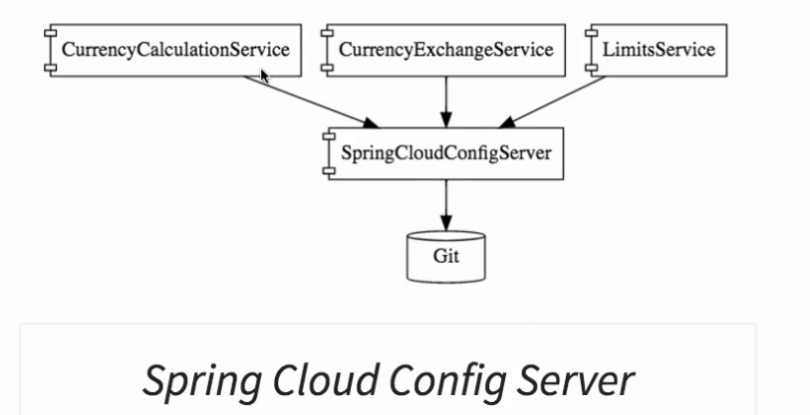

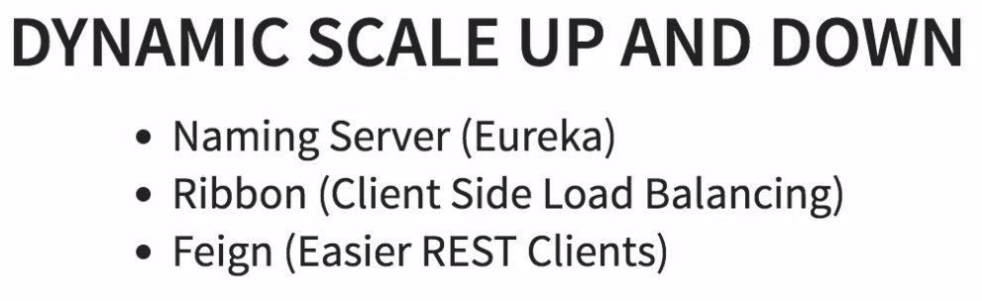

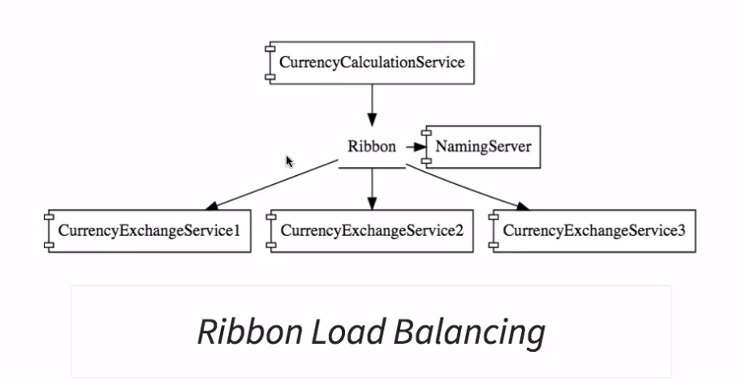

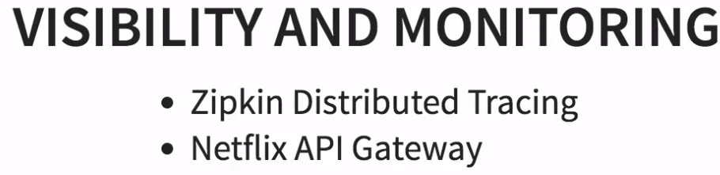

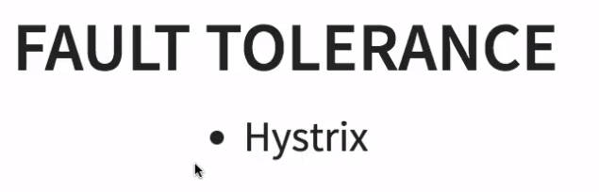

## Ports

| **Application** | **Port** |
| --- | --- |
| Limits Service | 8080, 8081, ... |
| Spring Cloud Config Server | 8888 |
|  |  |
| Currency Exchange Service | 8000, 8001, 8002, .. |
| Currency Conversion Service | 8100, 8101, 8102, ... |
| Netflix Eureka Naming Server | 8761 |
| Netflix Zuul API Gateway Server | 8765 |
| Zipkin Distributed Tracing Server | 9411 |

## URLs

| **Application** | **URL** |
| --- | --- |
| Limits Service | <http://localhost:8080/limits> POST -> <http://localhost:8080/actuator/refresh> |
| Spring Cloud Config Server | <http://localhost:8888/limits-service/default> <http://localhost:8888/limits-service/dev> |
| Currency Converter Service - Direct Call | <http://localhost:8100/currency-converter/from/USD/to/INR/quantity/10> |
| Currency Converter Service - Feign | <http://localhost:8100/currency-converter-feign/from/EUR/to/INR/quantity/10000> |
| Currency Exchange Service | <http://localhost:8000/currency-exchange/from/EUR/to/INR> <http://localhost:8001/currency-exchange/from/USD/to/INR> |
| Eureka | <http://localhost:8761/> |
| Zuul - Currency Exchange & Exchange Services | <http://localhost:8765/currency-exchange-service/currency-exchange/from/EUR/to/INR> <http://localhost:8765/currency-conversion-service/currency-converter-feign/from/USD/to/INR/quantity/10> |
| Zipkin | <http://localhost:9411/zipkin/> |
| Spring Cloud Bus Refresh | <http://localhost:8080/bus/refresh> |

